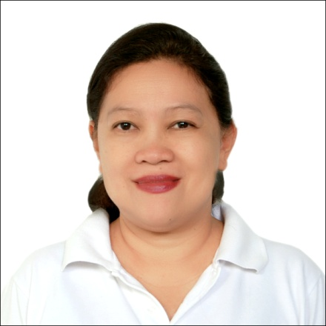
JOSEPHINE
Josephine.237211@2freemail.com
Personal Details
____________________________________________________________

Citizenship: Filipino
Gender: Female
Civil Status: Single

Qualifications and Education
___________________________________________________________

Graduate Studies: CPA-Certified Public Accountant
Professional Regulation Commission

College: Graduate of Bachelor of Science in Accountancy
University of Mindanao Davao College
Davao City, Philippines

Work Experiences

METAL LAND WORLD COMPANY
Al Quoz Industrial 3, Dubai , UAE

Accountant Handles all accounting jobs up to finalization of Financial Statement, does payroll and some PRO functions.

FIRST WELAN CORPORATION

Internal auditor (4 years)

- Travel between offices to conduct spot or scheduled audit.
- Conduct meetings with the Branch Operations Managers and employees for updated policies, and discuss any violations or un-implementation of existing policies and control system
- Report results of Audit directly to the CEO
- Create policy for the control system that suits the actual operation
- Executive Committee member
- Authorize to decide regarding company’s operations
- Give immediate solutions to any unexpected problems
- Attend monthly meeting among MANCOM (Management Committee) members

- Handle sensitive and critical issues with regards to company and its employees
- Part in planning future company’s direction
- Attend quarterly meeting to discuss company’s performance and company’s financial status
Admin & Finance Officer - Branch Office (3 years)

- Manage Office funds, collection, expenses, hiring & payroll preparation

POROCO INDUSTRIES CORPORATION/
SYNERGY DISTRIBUTION SYSTEM

Handled several positions:

Accountant/Bookkeeper (4 years)
- Record all transactions
- Do reconciliation of accounts, including Bank reconciliation
- Prepare Financial Statements
Audit member (1 year)
- Do Audit functions under the supervision of the Audit head

Accounts Payable/ Receivable Officer (2 years)
- Approve or disapprove customer’s purchase order
- Process payments to suppliers
- Reconcile variances
Warehouse Supervisor/ In-Charge (3 years)
- Practice good warehousing
  - Supervision and work designation of my subordinates
  - Conduct warehouse inventory

Biller/Encoder (1 year)

- Encode day to day transactions
- Generate sales report per salesman weekly, or as needed

Professional Membership
PICPA -Philippine Institute of Certified Public Accountants
Computer Skills
- Knows how to operate computer with Microsoft Word, Microsoft Excel and Microsoft Power Point Program
- Easily learns Accounting software used by the company
- Basic knowledge on how to operate oracle, SAP & Tally systems.

