NIKHIL
Nikhil.237285@2freemail.com
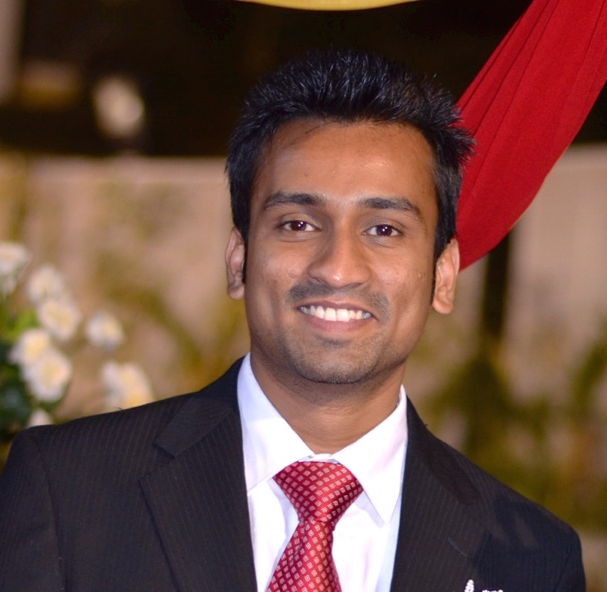

Summary
Customer Service Representative who maintains a high level of professionalism, patience and efficiency to minimize
customer dissatisfaction and increase customer loyalty.Skilled Technical assistant and Customer representative
committed to addressing customer concerns with speed, accuracy and professionalism with track record of developing a
quality call center workforce and consistently meets and exceeds productivity goals.
Highlights
Customer Relationship Management software Strong organizational skills
(CRM) Active listening skills
Proficient with Microsoft Office Suite Telecommunication skills
Troubleshooting skills Customer service expert
Strong problem solving ability Telephone inquiries specialist
Negotiation competency Linux (Ubuntu)
Devoted to data integrity ServiceDesk
Call center management experience OEM Certification
Employee relations specialist Critical thinker
High customer service standards
Experience
Customer Relations Advisor 05/2011 to Current
Tech Mahindra Business services Mumbai, Maharashtra
Improved customer ratings by 35%.
Implemented changes to customer service program, resulting in 30% higher customer satisfaction ratings.
Assisted in creating detailed product website that reduced average call time by 300 seconds.
Provided cross training to 20 staff members.
Assisted with the development of the call center's operations, quality and training processes.
Properly directed inbound calls in phone queues to improve call flow.Collected customer feedback and made
process changes to exceed customer satisfaction goals.
Built customer loyalty by placing follow-up calls for customers who reported product issues.
Ran reports and supplied data to fulfill customer report requirements.
Formulated and enforced Service Center policies, procedures and quality assurance measures.
Trained new employees and explained protocols clearly and efficiently.
Researched, documented and escalated cases to higher levels of support according to internal procedures.
Maintained a calm, professional demeanor when faced with high demand, high volume workloads.
Soft-sold additional services.
Techincal Assistant 01/2011 to 11/2015
Sutherland Global service Mumbai, Maharashtra

Set up and installed drivers on printers, including dot matrix, Inkjet and Laserjet.
Supplied technical and customer service support by phone and in person.
Fixed bugs as they were encountered.
Installed and performed repairs to hardware, software and peripheral equipment, following design and installation
specifications.
Conducted computer diagnostics to investigate and resolve problems and provide technical assistance and
support.
Analyzed network packet information and computer OS system data to identify and characterize anomalies on
networks.
Established requirements for new systems and modifications.
Technical Support Advisor 04/2008 to 11/2009
Stream Global Services Mumbai, Maharashtra
Troubleshot hardware issues and worked with service providers to facilitate repairs.
Created new account, reset passwords and configured access for users.
Developed and maintained technical expertise in Desktop and Laptop troubleshooting.
Reviewed support cases for technical and troubleshooting accuracy.
Identified opportunities to upsell product and services.
Delivered prompt, accurate and excellent customer service. .
Education
Bachelor of Commerce: Commerce 2008
Madurai Kamraj University Mumbai, Maharashtra, IndiaCetrified Hardware and Networking: Computed 2004
Government Polytechnic College Mumbai, Maharashtra, India

