/

CURRICULUM VITAE

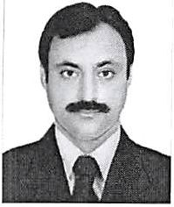

AMJAD

[AMJAD.237346@2freemail.com](mailto:AMJAD.237346@2freemail.com)

*Career Objective:*

Seeking a challenging and job oriented position in an industry with an esteemed organization where I can utilize my experience, education and enrich my skills.

*Professional Work Experience:*

•> Arabian Shopping Network LLC (ASN)

Driver cum Salesman May 25. 2012 to July 31, 2016

Duties and Responsibilities:

* Taking orders from the main office from call center agent.
* Delivering products to the customers as per their preferred timings and place.
* Explaining and helping customers to know more about the product on how to use it.
* Helping customers to assemble machines they have ordered.
* Driving every places here in Dubai and knows every corner in Dubai.

❖ Ishfaq Ahmed Laundry

Driver Cum Helper Jan 2001 to July 2012

Duties and Responsibilities:

* Responsible for collecting and delivering laundry to the customer houses.
* Ensuring that all the customer laundry has been collecting and delivered on time.
* Assigning cleaning and Dry cleaning for Laundry.
* Driving to all over Dubai For Delivering Laundry.

***Personal Information:***

Date of birth: Nationality: Languages known: Marital Status: Visa Status:

Jan 1st, 1977 Pakistani

English, Urdu, Arabic

Married

Visit Visa

Passport details:

Date of issue 17 Sept 2015 Date of expiry 16 Sept 2020 Place of issue Mardan Pakistan

***License Details:***

Issue date.20/08/2005 Expiry date. 17/02/2026