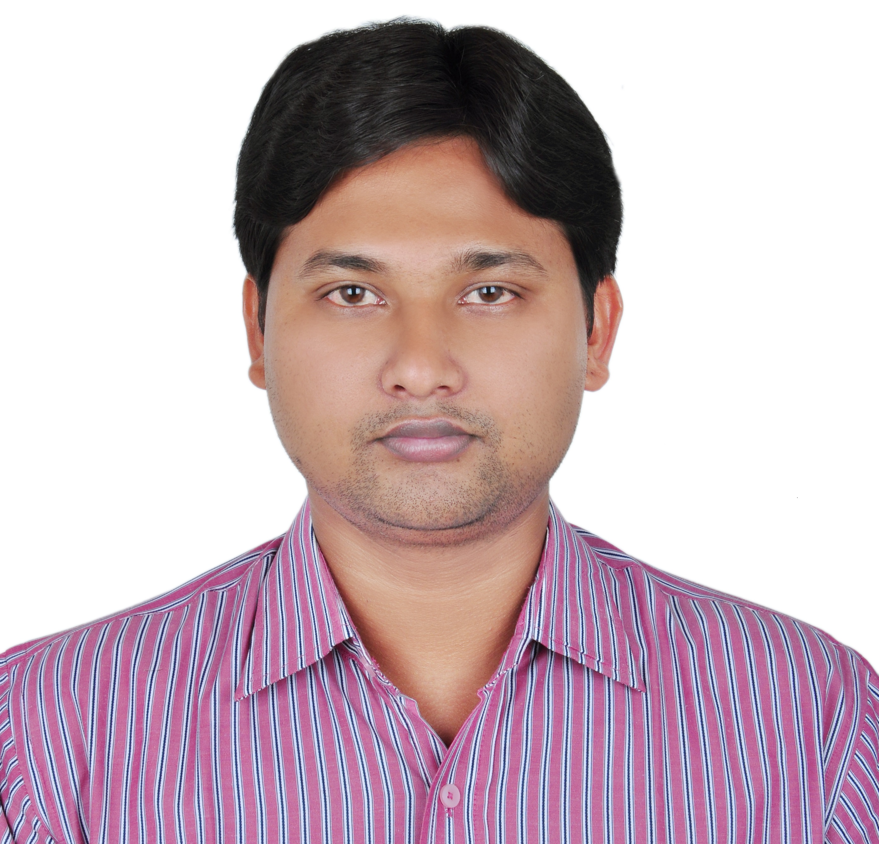
Gulfjobseeker.com

CV Number:
Mobile +971505905010 / +971504753686
E-mail: cvdatabase @ gulfjobseekers.com

To get contact details of this or many other candidates
Submit request on this link by writing all the short listed CV Numbers.
http://www.gulfjobseeker.com/feedback/submit_fb.php Gulfjobseeker.com

Date of Birth: 01.05.1988.

Nationality: Indian.

Languages known: English, Hindi and Bengali.
Hobbies: Involvement in voluntary works, Playing &watching cricket and Football, Reading, Listening to music.

As Electrical engineer by profession I am looking forward to pursue my career in the fields of Plant, construction and project management. I am also very keen to exploit my own abilities to the best possible limit and learn more along with the process. To work with honesty, integrity and dignity for a well-established organization and earn respect and recognition from peers and seniors. Willing to work as a key player in challenging and creative environment.

EDUCATIONAL QUALIFICATIONS

Degree in Electrical Engineering with DGPA of 7.33 from BIRBHUM INSTITUTE OF ENGG. & TECHNOLOGY College in the year of 2010.

AREAS OF INTEREST

- Project Management.

- Project coordination

- Site supervision.

A dynamic & result oriented professional with a 5 years’ experience in Multidisciplinary Management skills in two Turn-key Projects. Previously worked as an Asst. Manager - Maintenance in a leading construction company GPT GROUP since October 2010 has been associated with hospital projects under the banner of ILS Hospitals. Exemplary relationship management with good communication skills and has ability to network with project members, consultants, contractors, clients and statutory agencies.

WORK EXPERIENCE

Overall exposure to the Residential, Commercial and Infrastructure Development Projects.

- Organization: GPT Group (GPT Infraprojects Ltd.)

(Associated from 1st April 2010 – 28.02.2013)

O Designation: Asst. Engineer Electrical.

O Scope of work:

      - All Circuit Designing, Interior Light lay-out, Making BOQ.

      - Project Coordination & Site Supervision.

      - Contractor Bill making & checking.

O Projects:

      - ILS Multi-specialty Hospitals – 205 bedded – Agartala.
      - ILS Hospitals – 140 bedded – Dum-Dum, Kolkata.

Agartala Project - 100 Cr. Project of 205 bedded multispecialty ILS Hospitals consisting Nurses’ and Staff hostel, Docs’ quarter, Auditorium and Amphitheater.

Responsibilities:

- Cable lying of 11KV underground HT cable (120sq mm) having 04 KM long in depth of 1.5 Meter.

All internal and external Electrical Light and Power circuits.

Residential Building, Flats and Hostel total Light and Power circuits and positioning.
- Co-ordination with the Agencies like GE, Siemens, Otis, and BOC for all of their Electrical machines and prepare site condition as per their requirements.
- Supervision of total Air-condition work of this project. Testing of Chilled water pipe-lines, Fire pipe-lines and AHU, FCU and Hi-wall units.

2. Last Organization: GPT Group (GPT Healthcare Pvt. Ltd.),
ILS HOSPITALS, Agartala

(From 01.03.2013 – 31.08.2014)

O Designation: Asst. Manager - Maintenance.

O Scope of work: Working as HEAD OF MAINTENANCE ACTIVITIES of the entire 205 bedded hospital building Nursing School and residential campus of 400 employees. The job includes maintenance of

a) Building Infrastructure consisting of 9 story hospital building, Nursing school, 2 Nos. Staff Hostel (G+3 Story building), 1BHK, 2BHK, 3BHK Flat building, Auditorium on 4.5 acre land.
b) Electrical system-includes 990 KVA Transformer, 2 x 500 KVA Kirloskar DG Sets, HT Synchronizing panel, Power distribution systems and all electrical gadgets, 2X80 KVA UPS System.
c) Centralized AC System: including Chiller plant, Cooling towers, AHUs, CSUs, FCUs
d) Plumbing system: including water treatment plant, RO Plant, water line and distribution system, drainage system.
e) Medical Gas Pipeline system: Includes Oxygen Generation plant, Gas bunks (Oxygen, Compressed air, Nitrous Oxide, Carbon-di-oxide and central suction pump), distribution of pipeline in all 205 bed sides of the hospital.
f) STP (Sewage treatment plant).
g) 6 nos lifts.
h) All carpentry jobs of the hospital.
i) Fire fighting system: Includes 4 nos Fire pumps, Water Sprinkler system, Smoke detectors, Heat detectors, Fire extinguishers, Automatic fire annunciation panels
j) Transport system: Includes ambulances, bus, car etc.
k) Industry Laundry machines and kitchen equipment.
l) Biomedical Equipment: All biomedical equipment. .

3. Present Organization: (in UAE) (Prime Home Star Electromechanical LLC.)

(Associated from 14.09.2014 – till date)

O Designation: Project Engineer (MEP).

O Scope of work:
- All Circuit Designing, Interior Light lay-out, Making BOQ of all Mechanical, Electrical & plumbing items.

- Project Coordination & Site Supervision.
O Projects:
1. Al Ain University Hostel – Main Cable pulling from DBs to SMDBs and all power socket, switch board power wiring and fittings fixing. Also some of the ducting work.
2. Marina Tower, Dubai – All type of Electrical work like cabling, wiring, socket & light fixing of Residential typical flats.
3. Car Spa, Abu Dhabi – Fixing and Installation of DB & SMDBs. Armoured cable pulling and installation and all other Electrical Water proof fittings in the Car cleaning area. Carrier Split decorative AC installation.

COMPUTER SKILLS

Software known: MS Office, AutoCAD, Visual CAD.

PROFICIENCY FORTE

- Site & Construction Management, Planning & Billing.
- Preparing the contractor bill as per work order.
- Site co-ordination form head office regarding Materials, drawings, subcontracts issue to all projects.
- Involvement in making & approving subcontractor’s bill, taking site measurement for monthly invoices.
- Finalize requirements & specifications in consultation with collaborators / promoters as well as project scheduling including material & manpower planning.
- Execute HVAC, CCTV and all others LV works, interior works, little bit of civil, woodwork, plumbing etc.
- Ensure that equipment/materials received are in accordance with the quantity & quality.
- Network with architects/consultants/contractor to ascertain technical specifications, construction related essentials, based on the prevalent rules.
- Interaction with various Engineering disciplines and clients.
- Follow-up with Engineering & Procurement groups for achievements of targets.
- Established maintenance department of the new Hospital of ILS group in Agartala which includes mechanical, civil, electrical, carpentry, plumbing, MGPS (Medical Gas Pipeline system), STP (Sewerage Treatment Plant), Centralized AC Plant & Fire Fighting system, Lift and Biomedical engineering department. Written down SOP and implemented the SOP.

I hereby declare that all the information given above is true to my utmost knowledge.

Thanking You, Yours sincerely,

