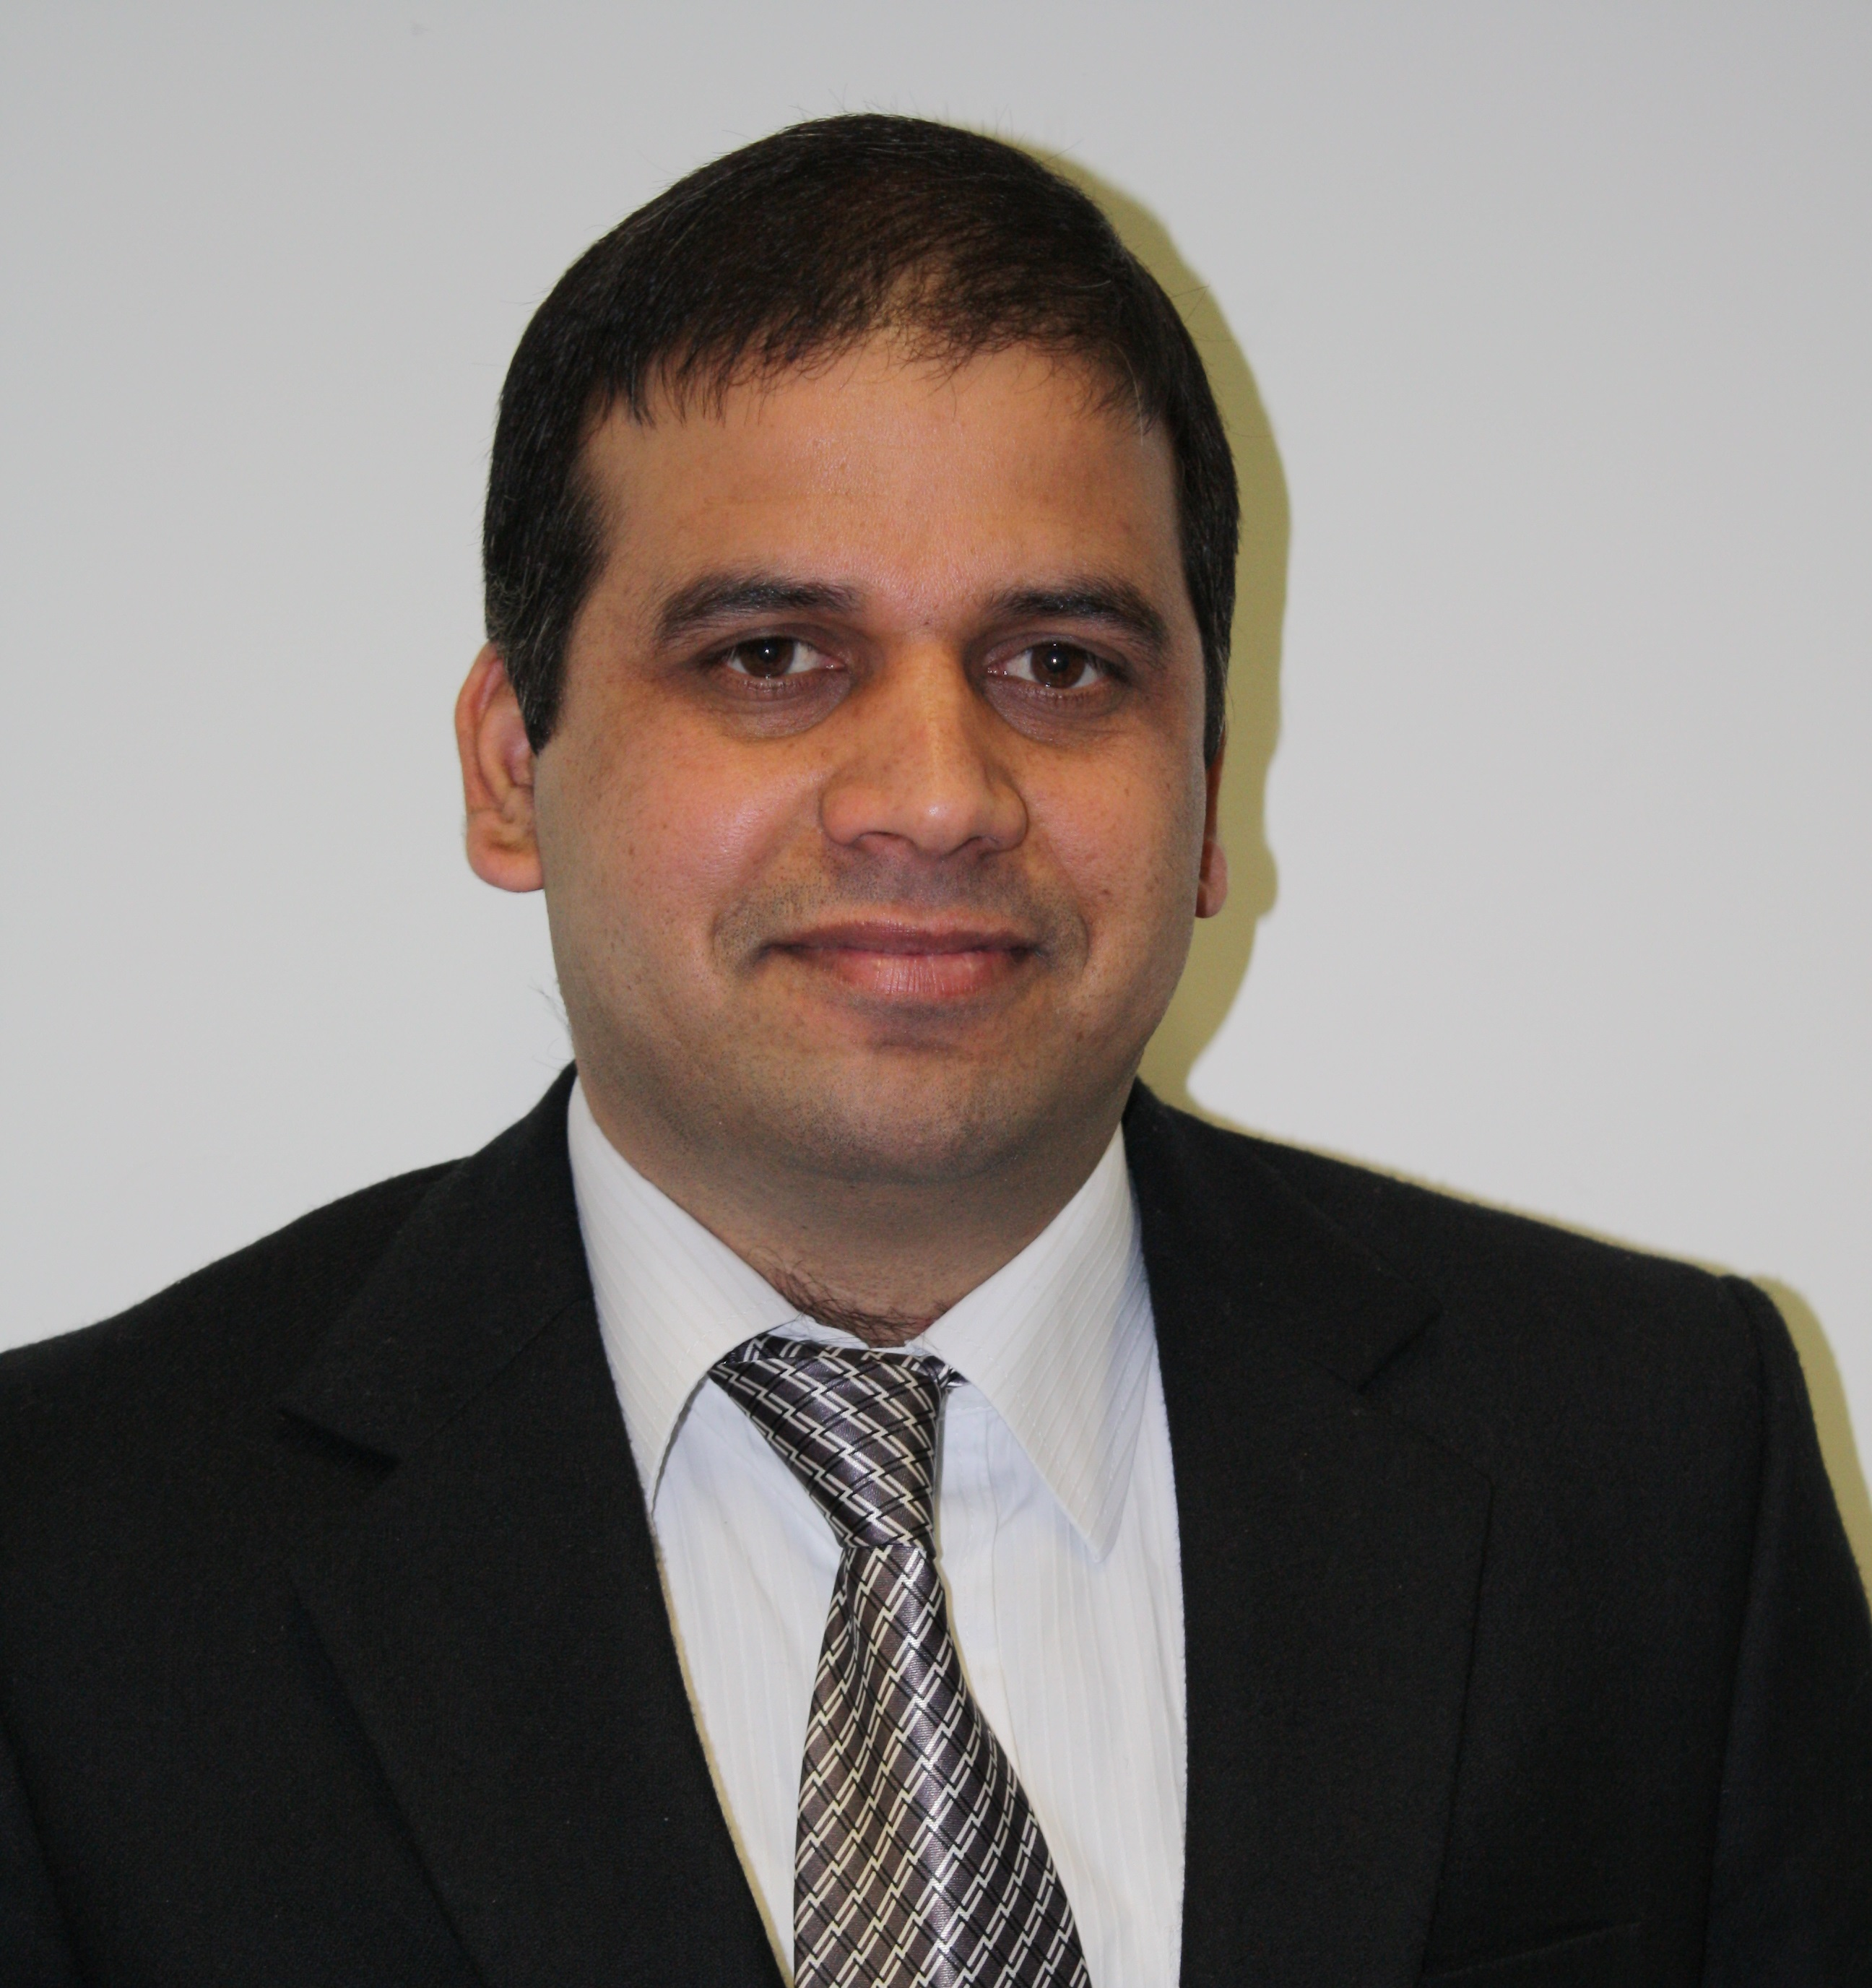
Arshad Mehmood (Software Developer)

DEIRA, DUBAI,
- +971-553720348, +923005084332
e-mail: arshad.bscs@yahoo.com
 skype id: arshad_vkk

Personal Profile
After exposure of more than four years in the IT industry a highly organized IT professional who has a proven track record of using good engineering practice to produce software for new, innovative and profitable products and solutions. At the heart of his strength is the ability to work on the development of software systems by accurately interpreting user requirements, then creating the required software designs, coding and testing them and finally integrating the software. At all times he makes sure that both the company’s and the client’s interests are at the core of any IT project.

Key Skills
Team Work:
- I have experience of teams working in task focused approaches.
- I am able to work as different roles within team.

Project Management:
- Fully able to meet aims and objectives during project life cycle.
- Motivating others to improve themselves.
- Prioritising and meeting deadlines.

IT Skills:
- Software Development methodologies (Agile, PRINCE2 and PMBOK).
- Professional level experience in Applications Development ( ASP.Net, VB.Net and C#).
- Good work experience in major software MS Office, Window Server 2003/2008, SQL Server 2005/2008/2010, Visual Studio 2008/2010/2012/2013, Netbeans Adobe Photoshop, Adobe Dreamweaver, Micro Media flash, HTML and many more.

Languages:
Fluent in English Urdu/Hindi and Punjabi.

Education and Qualifications
- MSc in Computer Science
University of Bedfordshire 2011~2012 (UK)

- BS in Computer Science
NUML University in December 2009 (Pakistan)

Short Courses
- Higher National Certificate (HNC) from University College of Advanced Technology, Pakistan.
- E-Commerce from National Institute of Computer Science, Pakistan.
- Leadership and Management certificate of training from University of Bedfordshire (UK)

Experience
Company : Wild Rabbit Limited
Location : Milton Keynes (UK)

(Work as .Net and C# developer)….June 2011 – Feb 2015 (UK)
Work as software developer within a team of highly motivated software engineers to deliver complex solutions to specific technical problems. Deeply involved in the designing, implementing and maintaining of software to support various client’s products and services. Work for both Desktop and Web based application by using Microsoft dot net technologies (ASP.NET, C#, SQL SERVER, VB.Net, MVC,WCF, Web Services, Store Procedure along with XLM, jQuery, HTML, HTML5, DHTML, CSS Java Script, AJAX, Adobe Photoshop, Micro media flash and many more.

Role and Responsibilities
My role and responsibilities are mention below.
- Designing, Implementation, Testing and maintaining phase of software development life cycle.
- Strong database knowledge specifically SQL Server 2005/2008.
- Expert level knowledge of ASP.Net, C# Programming, WCF, SQL SERVER, JavaScript, CSS, AJAX, HTML, XML and HTML5.
- Export data from database in any format e.g csv, txt, doc etc and vice versa.
- Knowledge of providing online support.

Interests and Activities
I always willing to learn new tools and technologies.
Reading books and learning new languages.
Playing computer games.

References
References will be available upon request.

