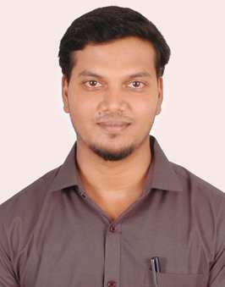

Victor Martin.S

MOOSA BUILDING,503,ALSOOR AREA,SHARJAH, svm1691@gmail.com

Sex: Male | Date of birth: 24/10/1991 | Nationality: Indian

WORK EXPERIENCE

JULY’14 – Present

EDUCATION

August ’10 – April ’14

August ’09 – April ’10

June ’07 – April ’08

Quality Engineer

Marks Engineering works, Coimbatore.

- Inspect the product based on customer drawings.

- Analyze quality performance utilizing using statistical and analytical tools and methods

- Identifying product defects to improve the quality, reliability and safety of the process.

- Supporting my team in reading the drawings.

- Ensure process control documents adhere with set requirements

- Collecting & analysing of feedback for continual improvement.

- Preparing master records of the finshed products

- Assist manufacturing scrap performance evaluation and management.

- Interact with manufacturing and engineering teams to optimize documentation related to qualityand inspection checks.

- Suggest corrective actions as material review board member.

- Software worked: AutoCAD 2007,2011,

Business or sector: Production,Manufacturing

B.E – Mechanical Engineering – 6.9 CGPA out of 10.

Karpagam college of enginering, Coimbatore.

Class XII – 75%.

AVB Matriculation Higer Secondary School, Coimbatore.

Class X – 62.6%

Sidha Naidu High school, Coimbatore.

PROJECTS

Double side reciprocating sawing machine using four bar mechanism

Unique bicycle crank

PERSONAL SKILLS

- Using four bar mechanism we are producing a two reciprocating motion by using links and with the help of this reciprocating motion we are cutting two objects in a single input

- . We fabricate a unique cycle pedal crank which is having two speeds,one for torque and another for speed.The belt and pulley used to power transferred for bicycle.

Job-related skills

Computer skills

- Effective communication with all department in our concern.

- Broad understanding of the product.

- Through knowledge in reading Drawings.

- Basic knowledge in AutoCAD.

- Basic knowledge in Microsoft office tools.

- Basic knowledge in Photoshop Cs3.

Linguistic skills | • Languages Known: Tamil, English
ADDITIONAL
INFORMATION
Co-Curricular Activities | • Attended a certification course on AUTO CAD at Karpagam College of
 | Engineering, coimbatore
 | • Secretary of MEXIHIBIT 2013 & 2014.
 | • Organized KONCURRENZA 2013 at Karpagam College of Engineering,
 | coimbatore
I hereby declare that the above mentioned details are true to my best knowledge.

Date: | Yours Faithfully,
Place: Sharjah (VISITING VISA 3MONTHS) | S.Victor martin.

