238203@gulfjobseekers.com
For the Post of Security Guard 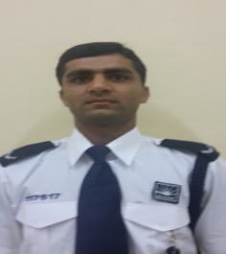
Objective:
A professional with a wide range of experience in security, safety & reception in private sector. Able to work on own initiative & as part of team .Proven leadership skills involving managing, developing & motivating teams to achieve their objective. First class analytical, administrative & problem solving skills. Dedicated to maintaining high standards, for success of the organization.
Personal Information:
Date of Birth 15-6-1994
Nationality Pakistani
Religion Islam
Skills:
- Very energetic result oriented & organized.
- Efficient & well behaved person.
- Extremely hardworking self motivate & able to work independently in the team environment under supervision.
- Keep excellent inter personal relations with colleagues & ready to help them.
- Key handling & dealings with the customer’s attention.
- Logging & reporting daily activities.
- Dealing with fire fighting equipments & fire panels.
- Dealing with health & safety related issues.
Academic Qualifications:
Group | Year of passing | Obtained Marks | Total Marks
Matriculation | 2012 | 551 | 1050
Intermediate | 2014 | 631 | 1100

Extra Qualification:
OSHA (Occupational Safety & Health Administration)
03 Months computer course from Joher Institute of Information Technology.
Basic computer knowledge about MS Office & 0ther different tools.
Languages:
English , Urdu , Punjabi , Pashto
Training:
Customer care training from Emrill Services Co LLC
Basic fire fighting training from Emrill Services Co LLC
Radio procedure training from Emrill Services Co LLC
Access control training from Emrill Services LLC
Safety training from Emrill Services LLC
Work Experience:
Currently employed in Emrill Services Co LLC as a Security Officer (Greens –Link Towers)
01 year experience as a security guard at MBK Trading Company (PVT) Ltd
01 year experience as a safety advisor at Saddam Construction Company.
06 months experience as a receptionist at Pak Saudi Tower
Personal Profile:
I am self motivated person who is diligent, ambitious, adaptable willing to learn & to take on new challenges.

