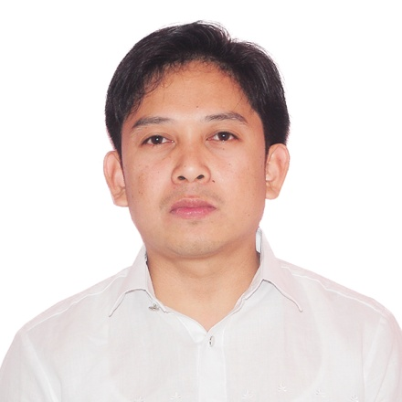
238514@gulfjobseekers.com

OBJECTIVE: To be employed in a Company that promotes enhancement of personal skills and provides opportunity for professional growth.

PERSONAL PROFILE

Age : 36 yrs. old
Birth Date : October 10, 1978
Height : 5’3”
Weight : 140 lbs
Interest : Research on new information technology.
Languages : Filipino, English

Educational Background

Tertiary :1995-2002
Course :Bachelor of Science in Business Administration
Central Colleges of the Philippines
#52 Aurora Boulevard, Quezon City

Work Experience

Euromax Businessmen Services LLC, Deira, Dubai, UAE
IT Support Engineer/WEB PROGRAMMER
March 2015 - Present
VISA STATUS- Tourist (date of expiration of visa is on July 2, 2015)

Duties and responsibilities
- Maintain the network working.
- Installation of cabling of network and telephone.
- Knowledge on web programming using PHP, NOTEPAD++, Photoshop, MYSQL, CSS Script, HTML.

Diamonds StarsPackaging Resources Co., Inc.
No. 7 Airforce Road, Holy Spirit, Quezon City
Inventory Control Specialist(June 16, 2014 to December 3, 2014)

Duties and responsibilities
- Use to check the data similarity.
- Check the software computation.
- Manage and support the flow of the inventory system.

Metasystems Development Inc.
4F Metasystems Building #2 Acacia Lane cor. Show Blvd. Mandaluyong City
Imaging Assistant (September 8, 2003 to September 10,2007).

Technical Support Engineer (Septermber 15, 2007 to December 10,2009)
As Helpdesk and Onsite Support at Amkor Technology Philippines under IBM Philippines management.
Technical Support Engineer (December 15, 2009 to September 6, 2010)
As Onsite Support and ImacDeployment Team at East Wood Project 1800 Building Libis under IBM Philippines management.
Technical Support Engineer (October 11, 2010 to June 30, 2013)
As Onsite Support and Imac Deployment Team at East Wood Project Swift Building Libis under IBM Philippines management.

As Onsite Support
- Installs software and hardware to clients, Anti-virus deployment and update.
- Maintain connectivity of users to the network.
- AS400 client installation and configuration
- Lotus notes (R8.5,R7,R6, R5, R4 and Version 8.5.2) installation, configuration and troubleshooting
- VPN and Wireless LAN installation on Laptop
- Desktop and Laptop troubleshooting (HP Compaq desktop, IBM T- series Laptop)
- DeskJet Printer(HP), Barcode (SATO, Intermec) installation and troubleshooting
- Configures and troubleshoots Tally Line printers, print servers, etc
- Create technical report for desktop replacements and upgrading, printer, additional accessories, etc.
- Back- up files, Format Desktops and Deploying windows Operating System
- Installs, Troubleshoots, Remote Troubleshooting Personal Computer, Printers, Computer Peripherals. Troubleshoots applications, Operating Systems, Utility software.
- Assist Administrators on updating patches, software updates, backup strategy, removing viruses and spam’s, threats, etc.
- Problem Isolation, System registry modification and O.S. Permissions.
- Patched LAN to specified ports, maintains patch panel over voice and data.

Technical Skills:
Software With knowledge in Windows NT 4.0,In depth knowledge of desktop operations, install, configure and navigate through Windows 3.1, 3.11, 95, 98, 2000, NT, ME, NT, Windows XP, Windows Vista, Windows Seven and Eight.Install and troubleshoot software faults using diagnostic utilities. Remote software (dameware, Radmin Real VNC AndPcanywhere).Norton Anti Virus, Office Scan. Installation and Configuration IBM Client Access, Reflection, ODBC and printer installation and configuration to print from AS400.VMwareWorkstation, SAP configuration and installation.

Hardware Install, troubleshoot and repair of PC’s peripherals like FDD, HDD, CD ROM, power supplies, CPU’s, sound cards, video cards, NIC, memory on both clone and branded unit like COMPAQ, IBM, HP, ACER, etc. Troubleshoot and repair on both DOT Matrix and laser, inkjet/DeskJetprinter like HP, Epson, Canon, Sato/Intermec Barcode printer etc. Identify system components, assemble and implement preventive maintenance.

Concepts and Connections Account and policies, Creates outage reports, software and hardware audits and inventories. Configure network printer and sharing, HP Jet Direct. TCP/IP protocol and RAS Configuration (Client and Server). Network Cards, Hubs Switches. Installation and Configuration of Wireless LAN Card. Host Protocol. Maintains a strong customer service orientation to ensure end-users/clients needs and expectations are satisfied.

Certification:

January 8, 2013 SARM(Security Asset and Risk Management)

February 1, 2013 Customer Service Training 101

March 15, 2013 Effective Business Writing 101

April 9, 2013 Problem Solving and Decision Making 101

