Shalini
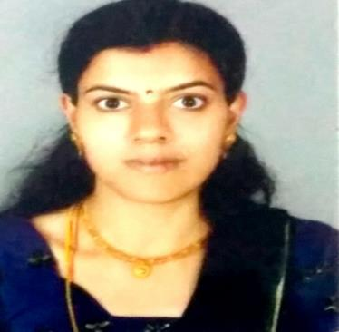
Shalini.239000@2freemail.com

----------------------------------------------------------------------------------------------------------------

CAREER OBJECTIVE

To obtain a challenging position that provides me the opportunities to exploit my knowledge and skill to the extreme levels of my ability and continually upgrade myself to the highest levels of expertise enabling the organization to achieve its target and growth.

ACADEMIC & PROFESSIONAL QUALIFICATION

- M.Com from Shri Shankaracharya Maha Vidyalaya (Affilated to Pt.Ravi Shankar University)Chhattisgarh in the year 2011.

- B.Com from Shri Shankaracharya Maha Vidyalaya (Affilated to Pt.Ravi Shankar University)Chhattisgarh in the year 2009.

- 12th from Shakuntala Vidyalaya (Affilated to C.G Board) in the year 2006.

- 10th from Jyoti Vidyalaya (Affilated to C.G Board) in the year 2004.

Technical Skills

- M.S. Office.

- Internet.

Certification

- Tally-ERP-7.2 & 9

PROFESSIONAL EXPERIENCE

Company: CA Suresh Jain & Co.

Position – Account Assistant

Period – Oct 2014 to Jan 2015

Job Description:

- Maintaining accounting record of daily transaction
- Preparation of financial reports like trading profit & loss & balance sheet

Institution: Krishna Public School

Position: Primary Teacher

Period – April 2009 to August 2014

Job Description:

- Maintaining Records
- Monitoring & Recording progress
- Developing & implementing lessons\work schemes
- Providing a safe & stimulating environment that facilitates learning
- Organizing & supervising play & work activities

ACHEIVEMENT

- Secure 1st position at school in 12th board exam.

CURRICULAR ACTIVITIES

- Actively participated in sports & dance at school level competition.

PERSONALITY TRAITS

- Hard worker & Sincerity.

- Ability to work as individual as well as in group.

- Highly motivated & eager to learn new things.

- Ability to produce result under pressure situation.

PERSONAL PROFILE

Personable and outgoing, comfortable communicating with people from diverse backgrounds, occupations, and cultures. Thrive on challenges and quickly adapt to new environments and responsibilities.

Languages Known: English, Hindi, Tamil

Date of Birth : 29 May 1988

Nationality : Indian

Marital Status : Married

Visa Status: Husband’s Sponsorship

