CURRICULUM VITAE

MOHD
MOHD.239131@2freemail.com
B.Tech(Mechanical Engineering)

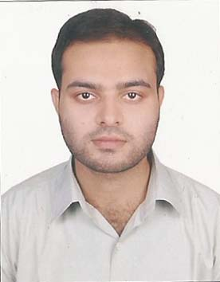
Objective:
A highly talented engineering with extensive knowledge in the field of Mechanical Engg. Looking for an entry level position as mechanical engineer in an esteemed
organization to achieve organizational goals.

S.No | Degree/Diploma | Board/University | Year | Percentage

1. | B.Tech (Mechanical Engineering) | ACN College of Engg. and Mgt.(UPTU) | 2014 | 67.91
2. | Diploma In Engg. | AMU, Aligarh. | 2009 | 85.96
3. | Matriculation | Infant Jesus School, ICSE BOARD. | 2004 | 60.00

GATE 2015 Scorecard:

- Percentile : 89.14% Valid upto : March 26, 2018.

Major Project : Hybrid Vehicle
Project Aim: Developing a highly effective Hybrid vehicle that uses two or more distinct power sources to move the vehicle. Designed for fuel efficiency and low emissions. This vehicle is completely eco-friendly.

Computer Skills:

- Proficient with MS office suite.
- Good Knowledge of CAD.
- Assembly and Maintenance of Computer and Networking.
Key Skills:

- Possessing In-depth technical knowledge and skills, competent with the challenging environment. Hardworking, energetic, and quick learner for any task delegated.
- Well verse with engineering drawings and principles.
- Solve problems analytically and logically
- Enthusiast to learn and constantly upgrade knowledge.
- Proficient in elaborating the plan in layman’s language and maintenance of existing mechanical system.

Personal Achievements:
-Won presentation on "Thermal Engg" at Inter-College level.
-Graduated with First Division.
-Qualified Diploma Engg. with First Position.
-Participated in Various College Tech-Fest.

Area Of Interest:
- Thermal and Power Engg. HVAC, Automobile.
- Casting, Welding and Manufacturing Process.
- Mechanics, Hydraulics.
- Testing and Maintenance.

Declaration:

I hereby declare that all the information mentioned above is true and complete to the best of my knowledge.

