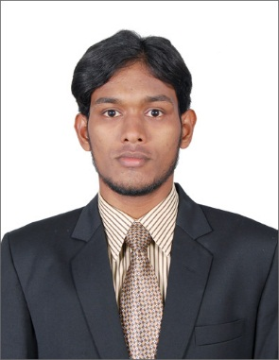
239297@gulfjobseekers.com
CAREER OBJECTIVE
To succeed in an environment of growth and excellence and earn a job which provide me job satisfaction and self-development and help me achieve personal as well as organizational goals.

PERSONAL SKILLS
Self-Motivated Person, Problem Solving Abilities, Team Facilitator, Challenge Accepting.

EDUCATION PROFILE
Indian Institute of Planning and Management Chennai,
MBA (70%) Graduated May 2014

Islamiah College Vaniyambadi,
BBA, (60%) Graduated April 2012

Islamiah Boys' Higher Secondary School Vaniyambadi,
HSC (60%) Graduated March 2009

COMPUTER SKILLS
- P.C.P + Tally9,
- Hardware & Networking
- Adobe Photoshop.
- MS office

EXTRA-CURRICULAR ACTIVITY
- NSS(National Service Scheme)
- Co-ordinated Ad-Zap at IIPM Chennai
- Attended Various Seminars during UG & PG Courses in various Topics
- Have done two Short movies along with classmates and friends as an actor and also edited the movie.

UG FINAL PROJECT
- Research for Leather Industry in “THW International” about job satisfaction in various departments in leather factory.

PG SUMMER INTERNSHIP
- Market Research in Top Notch Infotronix’s Brand “Zebronics” about Customer Satisfaction among Consumer Electronics.

PG FINAL THESIS REPORT
- Research on Rural Markets for FMCG products, Consumer behavior for the multiple brands of FMCG products and their queries and feedback for the same.

WORK EXPERIENCE
PropTiger.com Chennai
Assistant Sales Manager December 2014 - July 2015

- Convert Prospects into customers by showcasing appropriate Primary Residential properties to the prospects, which match the investment need of the Prospects. Take Prospects for Site visits in Residential projects, answering all relevant queries in the process, liaising with Developer or with PropTiger’s Developer Relations Team for any clarification required for that. Be compliant with operations process. Ensure that prospects and customers are satisfied with their interaction with PropTiger at all touch-points Provide after sales services and assist in Home Loans for the customers.

Papers Worldwide Services India Pvt Ltd Chennai
Business Development Executive April 2014 - November 2014

- Meeting with Advertising agencies, offset and digital printer, real estate companies, corporate offices to offer special Papers and boards for printing brochures, letter heads, business cards and other marketing collaterals. Negotiating with the concern person for price and giving discount or agency commission and closing the business.

DECLARATION:

I hereby declare that the information furnished above is true to the best of my knowledge.

