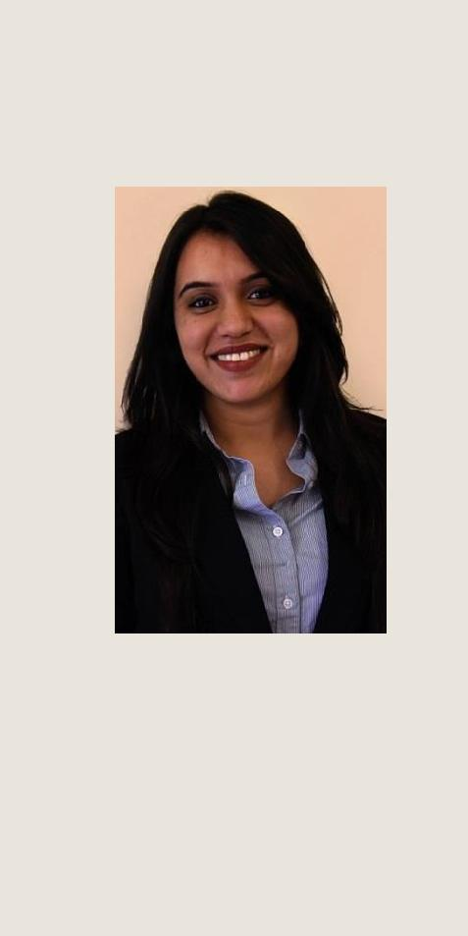

E-mail ID

kavithagovind.114@gmail.com

Nationality
Indian

Date/Place of Birth
04.11.1992 / Dubai, UAE

Address
P.O.Box: 48276
Al-Qusais 2, Dubai, UAE

Driving License
Valid UAE Driving License

Visa Status
UAE Residence Visa,

Father’s Sponsorship

ABOUT ME

An adaptable, hardworking and responsible graduate. I have a practical approach to problem solving, a focused mind at all times and a drive to see things through to completion. I enjoy working on my own initiative or in a team.

Page 1 of 2

KAVITHA GOVIND

Architectural Engineer

BEng (Hons)

EXPERIENCE

(June 2013 – July 2013)

JOHN R HARRIS & PARTNERS, DUBAI, UAE

ARCHITECTURAL INTERN
- Worked on and provided input in multiple projects.
- Attended team meetings with clients.

- Worked on AutoCAD and Sketch Up for multiple ongoing building design projects.

(August 2014)
MAGUS DESIGNS L.L.C., DUBAI, UAE

INTERIOR DESIGN INTERN
O Assisted the owner in analyzing design implementation problems.

(December 2014)
IMC HOLDINGS, DUBAI, UAE

INTERN

- Worked on a team project involving development and data entry of an upcoming online website in the tourism industry.

- Carried out field work for promoting a mobile software application for F&B outlets.

(August 2012)
TNS MARKET RESEARCH COMPANY, DUBAI, UAE

INTERN
- Worked on a telephonic survey project.
- Conducted a survey for The Dubai Yellow Pages.
EDUCATION

(2011 – 2015)

BACHELORS IN ARCHITECTURAL ENGINEERING-HONOURS

HERIOT WATT UNIVERSITY, DUBAI, UAE

(Summer 2011)
DEGREE ENTRY BRIDGING PROGRAM

HERIOT WATT UNIVERSITY, DUBAI, UAE
Kavitha Govid

SKILLS

WORK
MS OFFICE
AUTOCAD
SKETCH UP
IES VE
INFOWORKS CS

PERSONAL
COMMUNICATION
LEADERSHIP
ORGANIZATION
CREATIVITY
TEAM PLAYER
SOCIAL
LANGUAGES

ENGLISH
SPEAK, READ & WRITE

HINDI
SPEAK, READ & WRITE

ARABIC
READ

MALAYALAM
SPEAK

INTERESTS
ART
TRAVELLING
MUSIC
READING
TEACHING

Page 2 of 2

(2005 - 2011)

CENTRAL BOARD OF SECONDARY EDUCATION-12TH STANDARD
EMIRATES ENGLISH SPEAKING SCHOOL, DUBAI, UAE

 |  | CAREER OBJECTIVE
Seeking a | suitable position to apply the design and engineering skills
developed | through | my | education | and | internships.

REFERENCES

MR. FRANK NOWACKI – DIRECTOR

JOHN R HARRIS & PARTNERS

DR. HARPREET SETH

HERIOT WATT UNIVERSITY, DUBAI, UAE

DR. KIRK SHANKS

HERIOT WATT UNIVERSITY, DUBAI, UAE
PORTFOLIO OF PROJECTS

Available upon request.

Kavitha Govind

