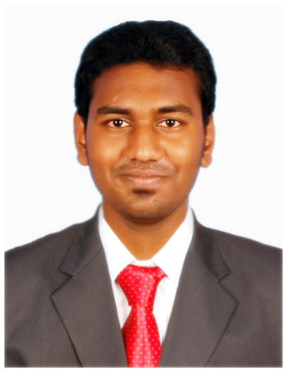
240573@gulfjobseekers.com

_____________________________________________________________________________________

Objective:
To earn a job which provides me job Satisfaction, self development, environment of growth and excellence and help me achieve personal as well as organization goals.

Skills, Competencies, Applications and Expertise:
- Banking – International Money Transfer [EUR-GBP-CHF-USD] and Investigations related queries
  - Human Resource – Experience in Pre and Post Recruitment
  - Financial Management, Cash Management, Accountancy
  - MS-Office, Tally, Oracle FLEXCUBE, STaRs, RECON, Global Interdict, Liquidity Monitoring System
- Typewriting - Passed with Distinction
- Image editing, Banner/Flyers designing using Photoshop and other tools
- Excellent communication skills both written and verbal
- Experience in handling queries via Telephone, E-Mail.

Work Experience Summary:
- Organization: Tata Consultancy Services Private Limited
- Designation: Process Associate –Funds transfer Investigator for Citibank EMEA Region
- Role : Information Processing Specialist
- Duration : October 2013– January 2015
Responsibilities:
- Experience in Swift messaging, International Payments, Domestics Payments and CHIPS
- Prioritizing, Investigating and acting on various online cash transfer related queries such as Amend beneficiary, Cancellation request, Unable to apply, Beneficiary non receipt of funds.
- Load files as required and analyzing, finding the errors and giving appropriate solutions for that.
- Taking appropriate actions on all new or pending files with status zero, and review the reopened files and take appropriate actions and Escalate/follow ups via mail for relevant pending / ageing / untimely cases
- Interact with customers by e-mail concerning various care issues on wire transfers and with Banks through Swift message, Telex, Fed service, E-mail and phone.
- Complete SDN (Specially designated Nationals List) check for any amendments received
- Monitor worklist, CITIFT queues, O/S Sundries & Receivables item throughout the day
- Review and complete reporting of various MIS requirement details
- Ensuring all messages and process items from worklist have been cleared

Previous Work Experience Summary:
- Organization: Tekflair Consultants Private Limited (clients are ACCENTURE, CAPEGEMINI, TCS)
- Designation: Associate – Talent Acquisition
- Role : IT & BPO Recruiter (contract-to-hire & Permanent hiring)
- Duration : January 2013– August 2013
Responsibilities:
- Going through various job portals to search suitable candidates & screening the profiles as per client requirements
- Proper screening & scrutinizing of candidates as per the requirements.
- Lining up of the candidates for interview in company & regular follow up with candidates & client till final selection
- Sharing costing details of the selected candidates to the clients for costing approval
- Initiating the joining formalities such as Database check and Background check for the candidates.
- After the green status for the candidates, making them to join within the given span of time
- Maintaining a healthy relationship with the candidates and building a strong database for future reference

Achievements, Awards & Recognitions:

 | TCS | Tekflair
AWARDS | On the Spot award (20-Jan-2014) | Best young performer of the Month award (2013)
REWARDS | 300 Gems for significantly contributing to team initiatives | Cash cheque ( worth 20% of my monthly Pay)
INITIATIVE | Was a part of KYP initiative of the business unit | NA
ACHIEVEMENTS | NA | Got a place in the Tekflair Wall-of-Fame

Education Summary:

Qualification Category | Qualification | Subject | % / GPA
Post-Graduation | MBA | HR & Finance | 74. 66 %
Under-Graduation | B.Sc - ISM | Accounting, Management & Systems | 70. 29 %
HSC | XII | Accounts, Commerce &Computer Science | 79. 18 %
MATRIC | X | Physics, Maths, Chemistry | 65 %

Academic Project Summary:

- MBA - Project in A.R.S Metals Ltd, Chennai [Title: Work-Life Conflicts]
- MBA - Project in Reliance Communications, Chennai [Title: Grievance Handling Mechanism]
- B.Sc. - Project in Robert Bosch Drives India, Chennai [Title: Corporate Social Responsibility]

