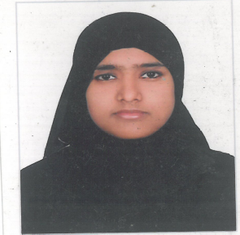
Gulfjobseeker.com CV No: 1444920
Mobile +971504753686, +971505905010
cvdatabase[@]gulfjobseeker.com
To contact this candidate use this link
http://www.gulfjobseeker.com/feedback/contactjs.php

Date of Birth : 23 July 1983
Nationality : Indian

OBJECTIVE:
Looking for an opportunity to work in Dubai as GP Dentist
(Full time straight or Part Time before 5 PM)

Total Experience : 7 years (2 yrs in Dubai, 4.5 yrs in India & 6 months in Libya)
Current status : Working in Dubai since June-2013
Qualification : Bachelor of Dental Surgery – B.D.S.
University : Rajiv Gandhi University, Bangalore, Karnataka - India.
Completion year : 2005
Internship : 2005 to 2006
Registration : Registered with Karnataka Dental Council, Bangalore, India

Computer Education:
- Microsoft Office

Other Certificates
- Pursuing Certificate programme of Basic Life Support for DHA standard, Dubai
- Certificate of “Ceramease… Ceramics Made Easy – 3M ESPE – Method of Zirconium crown”
- Certificate of “Roots to Success… Speed Up Your Endo – an advance technique for root canal treatment using rotary instruments” by IDA, Indian Dental Association.
- Certificate of Recent trends in medicine and dentistry – Organised by AKMG at Sheikh Rashid Hospial at Dubai , April 2010

Work Experience:
Professional Skill:
- Root canal treatment for Anterior and Posterior Teeth
- Ascertain the dental radiograph and analysis
- Anterior and Posterior Crown
- All kind of fillings
- Extraction of teeth
- Fixed Partial Denture
- Compete Denture
- Removable Partial Denture
- Scaling and Polishing
- Teeth bleaching / whitening
- Correction of Minor spacing, rotation of tooth using Hawley’s appliance.
- Good at handling pedo patient of all nationalities

Work History:

- Since June 2013 to till date, working at AL Dana Medical poly clinic as Dentist – GP, in Bur Dubai, Dubai

- 20th March 2010 to 15th November 2012, worked as Dentist with Smile Zone Dental clinic, Davangere, Karnataka – India

- 1st November 2008 to 15th August 2009; Worked as Dentist with Shaffi Orthodontic and Dental specialist clinic, Mangalore, Karnataka - India

- 19th September 2007 to 6th March 2008; Worked as Dentist with Private Al Jury clinic in Janzour – Libya.

- 27th November 2006 to 20th August 2007; Worked as Dentist with Shafi Ayurvedic Nursing Home (Dental Unit), at Mangalore, Karnataka, India

- 18th November 2005 to 17th November2006: Internship at College of Dental Science, Davanagere, Karnataka, India

------------------------

