RESUME

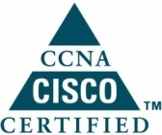
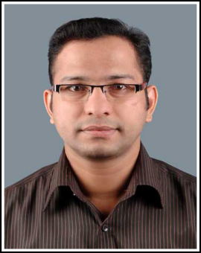
Jiju
Jiju.240851@2freemail.com
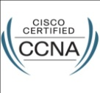

Objective

Seeking a challenging career in the field of Information Technology in a professionally managed company with learning and growth opportunities and thereby contributing to the progress of the firm.

Educational and Professional Qualification

- Electronics & Communication Engineering Diploma (DECE)
- Vocation Higher Secondary (MRDA) in Electrical & Electronics
- Perusing AMIE in electronics and communication engineering
certification and training

- Microsoft certified system engineer (MCSE) - MCSE

- Cisco Certified Network Associate(CCNA) - CISCO

- Apple(Macintosh),windows, Linux, Macintosh servers ,Red hat server

Virtualization Experience

- VM Ware using Virtual server handling experience ,

Professional Experience
- Duration : 20th sep 2010 to till date
Organization : Shalom Television
Designation : System Engineer
- Duration : 9th Dec 2006 to 27th Mar 2009
Organization : My choice computers – Bahrain (Middle East)
Designation : IT Support Engineer

PROFESSIONAL ACHIVEMENT
Design and implemented a world class video conferencing room with advanced facility. Migrated Linux os

job profile AND MAIN RESPOSSIBLITIES
Television Channel Experience
Configuring HARRIS and SOFTRON based play out Systems for broadcast. Supporting about 36 MACs and 270 PCs running MAC OS ,Yosemite, Mavericks X Leopard 10.6, 10.5x, Tiger 10.4x and Windows XP. Also supporting 7 systems

- Install configure and maintaining XSAN environment. FCP,PROTOOLS
- Configuring Deckling Black magic and Kona I/O Cards for Live output.
- Setting up and maintaining OS X 10.5 servers for XSAN and Open Directory with workstations running Portable Home Directories. Setting up RAID 0,1,5 on the MAC Pros
- Extensive knowledge of Apple Remote Desktop 3.2, including managing the entire Mac’s remotely, rolling out packages, doing software updates etc.
- Video conferencing system and Acoustic Room designing, CCTV, Bio-Metric Systems.

Storage experience
- EMC VNX5300 90TB Storage with brocade 300 fiber switch
- Promise VTrack Eclass 32TB Storage with with Q logic fiber switch
- NetGear NAS STORAGE AND G-SPEED STORAGE
SERVER experience
- IBM3650M4 Blade server ,Dell T20
- Mac pro server with MAC OSX
Workstations experience
- Dell Workstation T7600-1
- HP z620 ,HP Z600,HPz420,HP Z230
Firewall
FORTINET D90 and Fortinet B60 firewall installation configuration and Monitoring
Technical Skills

- Inter VLAN routing.
- OSI Layers, IP addressing Ipv4 and Sub-netting IP Routing- RIP, EIGRP & OSPF.
- LAN technologies STP VTP
- Installation managing and maintaining Microsoft server2003, Exchange server2003,Media Play out server(HARRIS,SOFTRON)

Projects and training

- Successfully completed a Project on “PC to PC Infrared Communication LAN”
- Trained in Solar Photovoltaic cell – Installation and Maintenance

Personal Information

Date of Birth: 14-02-1983
Nationality: Indian
Marital Status: Married
Language Known: English, Malayalam, Tamil, Hindi, Arabic (Bahrain)

Declaration

I hereby confirm that the information given above is true, complete and correct to the best of my knowledge and belief. I hope that this Resume would satisfy your need. I promise that I will insert my sincere effort if an opportunity is given to me. Until then, please take my best regards and God bless.

Respected sir,

I am submitting the enclosed resume for consideration of the system engineer (TV MEDIA)position my background has given me the hands on experience in IT SUPPORT in the field of television media particularly playout station and post production department and also web based television streaming and IPTV that would contribute to your organization‘s goals and objectives

The enclosed resume would reveal the numerous contributions made to my present employer that has benefited the bottom line

I am enthusiastic about exploring opportunities with television channels and look forward to meeting you I am expecting a favorable replay from you concern

Thank you for your consideration

