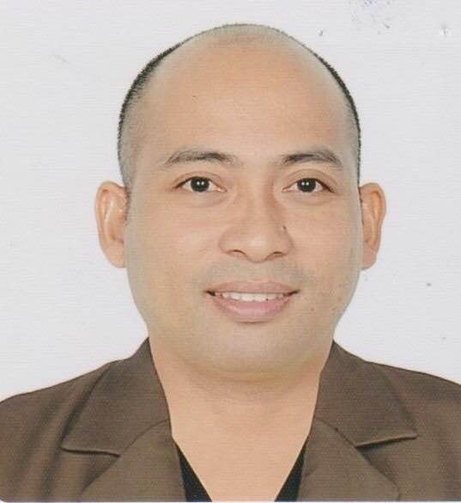

GEORGE
E-mail address: George.241179@2freemail.com

OBJECTIVE:

To obtain a position of Administrative Assistant with Company using a positive attitude, great attention to detail and accuracy, and a desire to succeed in a fast-paced environment to make a difference in the office administrative procedures.

EDUCATION:

BACHELOR OF SECONDARY EDUCATION
( Major in General Science)

Tertiary: Isabela State University
Cauayan Campus, Cauayan City
Isabela Philippines
2005-2006

Working Experiences:
Administrative Assistant
Administrative Assistant

I2i Inc. Astoria’s Group of Company 405 Libis, Quezon City, Philippines
February 28, 2005 to April 30, 2015
- Sort and distribute incoming mail to areas and staff within the organization and dispatch outgoing mail
- Write business letters, reports or office memos using word processing programs
- Answer telephone enquiries from customers, attend to visitors and assist other staff in the organization with their enquiries
- Operate a range of office machines such as photocopiers, computers and faxes
- File papers and documents
- Undertake other duties such as banking, credit control or payroll functions
- Word processing;
- Audio and copy typing;
- Letter writing;
- Dealing with telephone and email enquiries;
- Creating and maintaining filing systems;
- Scheduling and attending meetings, creating agendas and taking minutes - shorthand may be required;
- Keeping diaries and arranging appointments;
- Organizing travel for staff.
- Booking rooms and conference facilities;
- Using content management systems to maintain and update websites and internal databases;
- Managing and maintaining budgets, as well as invoicing;
- Liaising with staff in other departments and with external contacts;
- Ordering and maintaining stationery and equipment;
- Sorting and distributing incoming post and organizing and sending outgoing post;
- Arranging travel and accommodation for staff or customers and other external contacts;
- Liaising with colleagues and external contacts to book travel and accommodation;
- Organizing and storing paperwork, documents and computer-based information;
- Photocopying and printing various documents, sometimes on behalf of other colleagues;
- Recruiting, training and supervising junior staff and delegating work as required;
- Manipulating statistical data.

I hereby certify the above information is true and correct to the best of my knowledge and belief.

GEORGE
Applicant

