CURRICULUM VITAE
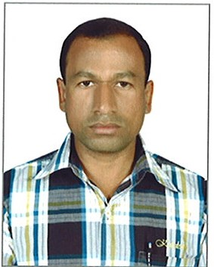

Sirajudeen
Sirajudeen.241746@2freemail.com

Carrier Objective:

I would like to associate myself with an organization where there is an ample scope for individual as well as organizational growth and development. I want to be a part of a team environment applying extensive background in team building – motivation, superior problem solving skills with management and communication skills and a position where honesty and enthusiasm are appreciated.

Work Experience Summary:

- Working as Accountant in Abu Dhabi Co-operative Society, Abu Dhabi - UAE from June 2007 to Till Date.

Company Profile:

Abu Dhabi Co-Operative Society is the premier retail organization in the Abu Dhabi. Abu Dhabi Co-Operative Society (ADCOOPS) is a Joint Stock organization fully owned by the citizens of the Emirates. As Abu Dhabi Co-Operative Society Holdings, the company is diversified into various business segments, complimenting the core business of Retail from Hypermarkets, Supermarkets, and Retail parts to Electronics Superstores, InfoTech, Real Estate Franchise operations & Investment. Abu Dhabi Co-Operative Society is the flagship member of the Consumer Co-operative Union of UAE.
Job Responsibilities:

- Preparation of Final Accounts (It Includes Profit and Loss & Balance Sheet
- Preparation of Income and Expenditure Accounts
- Maintaining Ledger Accounts
- Responsible for all account work dealing with purchase
- Payable accounting Reconciliation review and follow-up
- Sound expose to Computerized accounting
- Reconciliation of Supplier Statements
- Monthly Clearance of Supplier Out Standings
- Preparation of Debi & Credit Notes

- Worked as an employee with K. Kannan, Sales Tax and Income Tax Practioner in Villupuram, and Tamil Nadu from May 2003 to Jan 2007.

- Worked as a Sales Man at S.V.S & Sons, Veg. Oil Refinery Villupuram, and Tamil Nadu from Feb 2000 to Nov 2002.

Educational Qualification:

- 1997 - B.A Corporate Secretary ship from C. Abdul Hakeem College, Vellore (Affiliated to Madras University)

Academic Project:

- Underwent a Institutional training for a period of 15 days at “TAMIL NADU INDUSTRIAL EXPLOSIVES LIMITED”, VELLORE, TAMIL NADU (A Government of Tamil Nadu Enterprises)
Technical Qualification:

Typewriting : English (Higher)

IT SKILLS
Operating systems : Xp, Window 7
Financial Accounting : Tally 9, Navision & Windows Dynamics 2012
Office Package : Ms-Office (MS-Word, MS Excel, And MS-Access, MS PowerPoint)
Web Technology : Internet Services.

Soft Skills & Attributes:

Analytical abilities
Sharp learning curve
Hard working
Supportive team member.

Personal Profile:

Date of Birth : 27.06.1974
Gender : Male
Marital Status : Married
Languages Known : English, Tamil & Malayalam
Nationality : Indian

Declaration:

I hereby declare that the information furnished above is true and correct to the best of my knowledge and belief.

