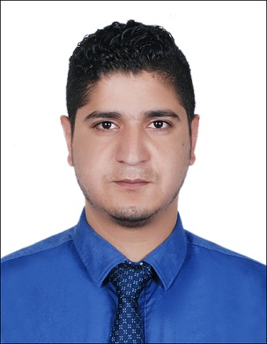
Name: Khalid Bashir
Address: Al Riga, Deira Dubai
Visa Status: Visit Visa
E-mail: khldbhatt60@gmail.com

CAREER OBJECTIVE

Looking for an opportunity to work in creatively challenging environment and utilize my technical abilities and skills towards achieving the goals of organization. I am also very keen to exploit my own abilities to the best possible limit and learn more along with the process. To work with honesty for a well-established organization.

EDUCATIONALQUALIFICATIONS

B.Tech in Electronic Communication Engineering from Uttrakhand Technical University

HSC from Jammu and Kashmir Board of School Education

SSC from Jammu and Kashmir Board of School Education

PROFILE

Strong administrative and organizational skills.

Work both effectively as a team member and independently.

A flexible professional with good time management.

Experienced in problem solving and multi-tasking skills.

WORKEXPERIENCE

A dynamic and oriented professional with 3 years of experience in Kishan Ganga project worked as Junior Electrical Engineer.

Organization: PES (PES Engineers Private Ltd.)

(Associated from July 2012 – July 2015)
Designation: Junior Engineer Electrical.

Scope of work:

      - All Circuit Designing, Interior Light lay-out

      - Project Coordination & Site Supervision

      - Contractor Bill making & checking.
Responsibilities:

To develop and maintain electrical control system or components required specifications on economy.

To design and manufacture electrical equipment for use of building, including lightning and heating.

Visit construction sites to observe conditions impacting design and to identify solutions to technical problems.

Attending meeting on site.

Identifying customer requirement.

All internal and external Electrical Light and Power circuits.

Residential Building, Flats and Hostel total Light and Power circuits and positioning.

All type of Electrical work like cabling, wiring, socket & light fixing of residential.
and typical flats.
Carrying out electrical design calculations on a variety of buildings within
different sectors.
TECHNICALSKILLS

One Year Diploma in Computer Application.

Certificate in CCNA.

Mat Lab.

SUMMER INTERNSHIP

- Title: - Design and Implementation of LCD display interface using VHDL

For XILINX FPGA

Company: - ARDENT COMPUTECH PVT.LTD

Duration:- 42 days

- Title: - Classification of Mammography using Naive Byes Classifier.

Duration: - 6 months

HOBBIES

Travelling

Shopping

Cricket

LINGUISTIC ABILITY

English

Urdu

Hindi

Kashmiri

PERSONAL DETAILS

Fathers Name: - Bashir Ahmad Bhat

Mothers Name: - Javeeda Jawhar

Sex: - Male

Nationality: - Indian

D.O.B:- 12-Jan-1989

I hereby declare that all the above statements are true to the best of my knowledge.

