CURRICULUM VITAE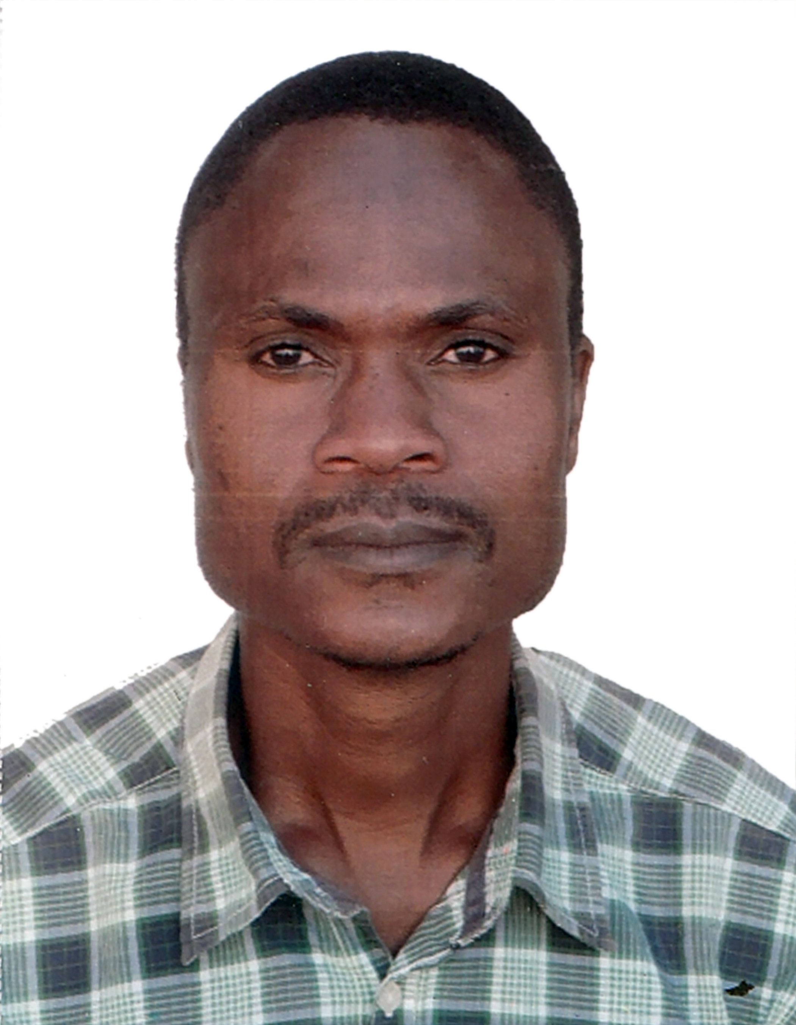  Personal Data:  Nationality: Zimbabwean  Visa Status; Visit visa  Professional skills  Communication  Skills, | TUTSIRAYI CV NO. 150210  Whatsapp Mobile: +971504753686 Phone +97143970978 E-mail: gulfjobseeker@gmail.com    OBJECTIVE  To obtain a position in a progressive and esteemed organization that will fully utilize my professional skills while giving space for self-development, career growth & experience.  PERSONAL ATTRIBUTES  - Trustworthy, friendly and approachable Positive team player with an outstanding work ethic, flexible and dependable  - Easy adaptation to new activities and eager for new challenges.  - Proven ability to learn quickly, able to prioritize work to meet deadlines.  - Courteous and considerate  - Consistent to duty  - Well regarded for, safety practice, written and oral communication skills  WORK EXPERIENCE  CE PLANT HIRE (SOUTH AFRICA)  POSITION – WELDER 2013-2015  - Repairing of dented parts of tipper trucks such as bumpers, light brackets, buckets , etc  - Fabricating different parts to be fitted  - Welding on of liner plates on to buckets of  tipper trucks, excavators, TLB and Bobcats  KHUBONI PLACEMENT (PVT)LTD (CC GENRER)(SOUTH AFRICA)  POSITION :BOILERMAKER 2012- 2013  Duties and Responsibilities  - Reading blue prints ,measuring ,making out, flame cutting,  - Grinding, squaring, punching, fabrication of beams, columns.  - Fabrication of roof trusses, gussets, stiffeners, joining of items by means of welding, riveting  - Housekeeping.  COSMOS TRAILERS (PVT)LTD 2007-2010(SOUTH AFRICA)  Position :TRAILER BUILDER,WELDER  Duties and responsibilities  - Reading blue prints and sketches  - Measuring, marking out, cutting, and joining of material by means of mig welding.  - Fabrication of boat, Jet Ski and motor bike trailers.  - Mentainace and servicing of trailers  EDUCATION QUALIFICATIONS  National Certificate in Fabrication Engineering  Certificate of Skilled Worker Qualification  Ordinary Level certificate  Interests and hobbies  - Reading  - Travelling  - Playing soccer  References available upon request

