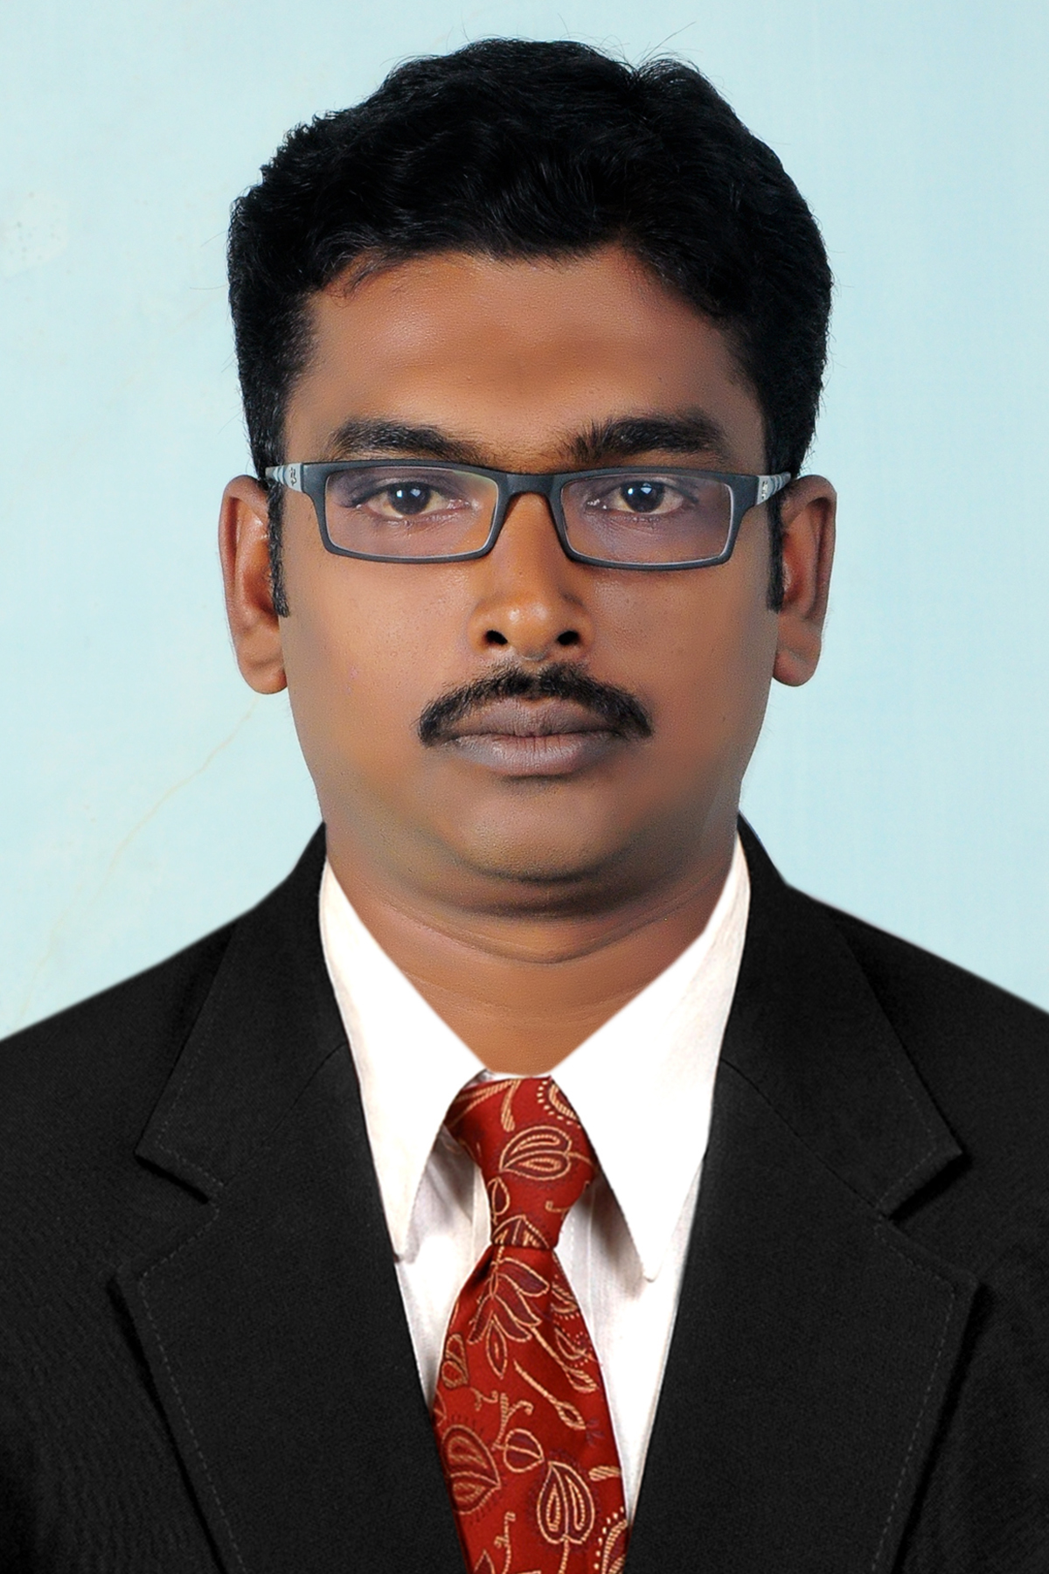

VINITH CV No 152412
Whatsapp Mobile: +971504753686 Phone +97143970978 E-mail: gulfjobseeker@gmail.com


CAREER OBJECTIVE

To seek an opportunity to work in an environment where I could improve my skills, abilities and contribute towards the growth of organization. To assist in every possible way to learn the Work Ethics, Culture and Organizational operations and methods.

EDUCATIONAL QUALIFICATION

Course | Institution | University/ Board | % | Year of  Passing
MBA (Marketing with Finance) | Asan Memorial Institute of Management | University of Madras | 71 | 2012
B..F.T(Bachelor of economics with foreign trade) | V.T.B COLLEGE, MANNAMPATTA PALAKKAD, Kerala | Calicut University | 60 | 2009
H.S.C | GHSS VELLENEZHI, PALLAKAD DISTRICT, Kerala | Higher Secondary Board Kerala | 66 | 2006
S.S.L.C | JANA VIKAS ENGLISH MEDIUM SCHOOL, COORG DISTRICT , KARNATAKA | KARNATAKA STATE BOARD | 67 | 2004

EXPERIENCE

Tech Plast Pvt Ltd (2012-2013)

- Worked as marketing executive in automation industry
- Worked in a group of 4-5 people to develop new clients in India.
- Responsible for communication to clients over phone and through mail.
- Work Profile:
- Joined the company as management trainee
- •Going on field with seniors to study the market and customers of the company
•Generating enquiries for the company and converting them to customers
•Studying market the company products as compared to other companies
•Assisting seniors in daily activities
- Other projects:
Sankar sealing Systems Pvt Ltd (2013-2015) sankar sealing systems is a manufacturing of all types of auto mobile gaskets 9002 accredited
Worked as a senior sales marketing executive
- meet up with the clients
- meeting the sales target.
- raise the invoice
- maintain relationship with the clients provide the after sales support
- team handling experience of ten members
work profile
sales:Taking care of sales with focous on achieving predefined sales target .forecasting quarterly monthly sales targets and executing them in a given period of time .

Marketing:Analysing the market trends and tracking competitors activities and provide valuable inputs to the team.

Business development;Executing the long term business directions of the region to ensure maximum profitability in line with organisational objective

Operations :Managing activities pertaining to negotitation/finalization of deals for smooth execution of sales and order processing.

management Relationship:Ensuring customer satisfaction by achieving delivery timelines and service quality norms.

Achievements:
Won 2 time full attendance award
MD appreciated the presentation conducted by mine in annual sales meet
Sales manager appreciated for achieving the monthlyTarget

Expertise
- Marketing , Sales , advertisement, promotion
- Hr related activities (payroll, attendance , recruitment)
- Purchasing (negotiationof bills) bill raising , team handling,good comunicator between employers and management.

Skill s

Strong communication skills
•Team player
•Strong analytical skills
•Convincing ability
•Willingness to learn
•Strong interpersonal sills

ACADEMIC PROJECT WORK TRAININGS
- 60 Day project in “A STUDY OF BRAND AWARENESS AMONG THE CHENNAI METROPOLITIAN CUSTOMERS TOWARDS GETIT YELLOW PAGES” in Getit Yellow pages
- 45 day project in in “KONE ELEVATORS”(ORGANIZATION STUDY)STUDYING THE ORGANISATIONAL STRUCTURE OF A COMPANY
EXTRA CURRICULAR ACTIVITIES

- Win prices in intercollegiate tournaments like debate, essay writing , quiz competition,
- Participated in brand management competition
- Organizing marketing competition at inter-college level
- Active participation in Sports and Games in Schools and colleges.
- Participate in state level Kabbadi tournament in Kerala (palakkad dt captain seniors)
- Participated in state level Kabbadi tournament in Karnataka ( juniors

PERSONAL INFORMATION

- Date of Birth : 09--06--1987
- Nationality : Indian
- Languages : Malayalam, English, Hindi Tami l kannada Telugu
- Hobbies : Dancing, Reading, Internet surfing
- Technical skill : Microsoft office, windows xp,internet application

