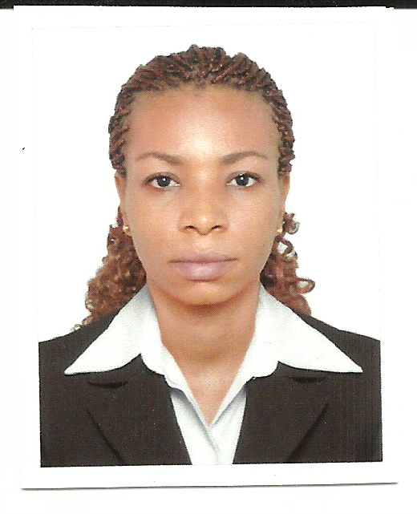

Gulfjobseeker.com CV No: 1458216
Mobile +971504753686, +971505905010
cvdatabase[@]gulfjobseeker.com

To contact this candidate use this link
http://www.gulfjobseeker.com/feedback/contactjs.php

PROFESSIONAL HIGHLIGHTS
Efficiency in computer skills: Office applications,
speed in typing. Ability and desire to learn quickly.
Excellent communication skills and articulate speaker.
Creative and dedicated to achieving setout objectives.

WORK EXPERIENCE
Midea Social, Psychological and Family Consultancy,
Ajman, U.A.E. July 2015-till date.
Designation: Receptionist
ROLES AND RESPONSIBILITY
- Welcoming guests or customers with smiles or a cheerful look, directing them to
the appropriate place.
- Taking telephone calls from the customers, assisting them with enquiries.
- Relating with customers, achieving and meeting Challenges.
- Maintain professional relationships at work.
- Keeping to the rules and regulations of the company and always present at the
duty post.
- Maintains safe and clean reception area by complying with procedures, rules, and
regulations.
- Maintains continuity among work teams by documenting and communicating
actions, irregularities, and continuing needs.
- Contributes to team effort by accomplishing related results as needed.

Tulip Sweets, Al Fujairah.U.A.E. Jan 2015-April 2015.
Designation: Sales Representative
ROLES AND RESPONSIBILITY
- Ensure that the customer's satisfaction is met.
- Process orders in person and over the phone.
- Check inventory to ensure product is in stock.
- Making incident report and handling them out to the management.
- Accessing my work environment and suggest of ways of improving it in order to meet customer's needs.
- Provide a high profile of quality customer service on my work location.
- Handled all assigned complaints and problems properly to the customer's satisfaction
- Problem solving and conflict resolution techniques, following established policies and procedures meeting customer’s needs.
- Greeting and welcoming customers, providing outstanding customer service on my duty location.
- Maintain high standards of personal appearance and grooming.
- Process orders in person and over the phone
- Report all complaints and problems of the customers to the management.

Presidential Hotel, Nigeria. 2013- 2014
Designation: Receptionist
ROLES AND RESPONSIBILITY
- Collect and research information needed to identify and resolve problematic situations .
- Serves visitors by greeting, welcoming, and directing them appropriately, notifies company personnel of visitor arrival, maintains security and telecommunications system.
- Conduct outbound lead follow-up calls to potential and existing customers via telephone and e-mail to qualify leads and to sell products and services.
- Welcomes visitors by greeting them, in person or on the telephone; answering or referring inquiries.
- Directs visitors by maintaining employee and department directories; giving instructions.
- Maintains security by following procedures; monitoring logbook; issuing visitor badges.
- Maintains telecommunication system by following manufacturer's instructions for house phone and console operation.
- Maintains safe and clean reception area by complying with procedures, rules, and regulations.
- Maintains continuity among work teams by documenting and communicating actions, irregularities, and continuing needs.
- Contributes to team effort by accomplishing related results as needed.

GOD’S POWER TRAVELS AND TOURS, Nigeria. 2011-2013
Designation: Secretary / Receptionist.
ROLES AND RESPONSIBILITY
- Meeting the needs and desires of the customers.
- Welcoming guests or customers with smiles or a cheerful look, directing them to the appropriate place.
- Taking telephone calls from the customers, assisting them with enquiries.
- Relating with customers, achieving and meeting Challenges.
- Ensure rules and regulations are followed appropriately at work.
- Maintain professional relationships at work.
- Keeping to the rules and regulations of the company and always punctual at work.

Skills:

Telephone Skills, Verbal Communication, Microsoft Office Skills, Excel and Internet, Listening, Professionalism, Customer Focus, Organization, Informing Others, Handles Pressure, Supply Management.
EDUCATION
B.Sc. Psychology 2004-2008.
Enugu State University of Science and Technology, Enugu Nigeria.
High school certificate 1997-2002.
Community High School Udi, Enugu State, Nigeria 1991-1996.

PERSONAL DETAILS
Date of Birth : 11th December 1985
Nationality : Nigeria
Visa Status : Transferable Visa
Marital Status : Single
Gender : Female
Language : English

HOBBIES:
Reading and Researching.

