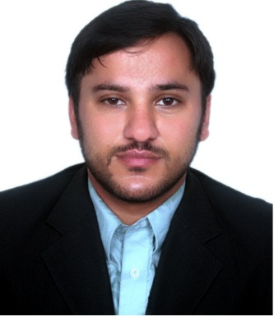
Raffaq
Raffaq.243154@2freemail.com

OBJECTIVE

Meritorious, scholarship holder, Bachelor of Science in Software Engineering pass out with zeal to grow in the field of Software development and Networks. Looking for an organization to provide my skills and knowledge that can be a valuable asset to the growth of any organization.

Academic Qualification

- 2014: BS Honrs Software Engineering (Mirpur, Pakistan).
- 2010: FSC (68.1%) (Pre-Engineering).
- 2008: Matriculation (78.9 %) (Science).

Technical Qualification
- Microsoft Office Word, Excel, Access, Powerpoint, Outlook etc.
- System Configuration and Maintenance.
- Networking knowledge of LAN, WAN, TCP/IP, SMTP, VPN, DNS, UDP, EIGRP and OSPF etc.
- Database Development and Maintenance.
- Systems Engineering, Windows and UNIX systems.
- Communication Protocols and Computer Architecture.
- Web Designing and Web Programming (design According to usability principles).
- Software Quality Engineering.

EXPERIENCE

Name of Company: Telesquad LLC
Designation: System Administrator & Web Developer
Duration: (1 Years and 0 Months)
Place: (Rawalpindi, Pakistan)

Responsibilities:

- System Configuration (Networking) & Maintenance.
- Troubleshooting the Network.
- Website Development & Maintenance.
- Database Development & Maintenance.
- IT Support.
- Software Quality Assurance.
- Other Computer Operations.

Achievements

- Provided user requirements analysis, design and programming Support for
Enhancement of Website accessed by 5 million user worldwide.
- Resolved multiple issues to network system to increase business functionality.
- Initiated Network enhancements that reduced network downtime from 30% to nearly 0%.
- Interfaced with users to provide permanent solutions to recurring issues.
- Fueled additional revenue stream through responsive customer support generating
$ 15k in new license sales within first few weeks of new product release.
- Supplied back-up and documentation of computer and security systems.
- Personally handled on-site analysis, inspection, and implementation of proposed solutions.
- Monitored service quality involved in daily contact with end-users to troubleshoot and resolve problems.

LANGUAGES
English, Urdu, Hindi, Punjabi
PERSONAL
Date of Birth : 12/10/1991
Place of Birth : Pakistan
References : Can be furnished on request

I hereby certified that the above statements are true and correct with all my knowledge and also to the help of our Lord. After you’ve reviewed my resume, I would welcome an opportunity to discuss your company’s goals and talk to you about the value that I can bring to your Company. More Power and Positive energy blessed.

