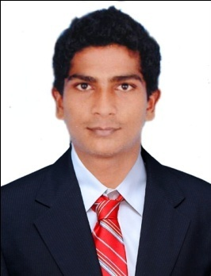
CURRICULAM VITAE

JACOB
JACOB.243695@2freemail.com

CAREER OBJECTIVE
- Seeking for a full time and permanent position of Mechanical Engineering and Supervising where product development
- Extensive knowledge in field of mechanics
- Efficient in working at fast place environment and excellent organizational interpersonal skills
- Excellent data analysis reporting skills using statistical methods and software
WORKING EXPERIENCE
- Working as Mechanic Training in TATA motors in six months.
- Working as SKODA auto as Maintenance Engineer from June 2013 to July 2015 in India.
- With Good Working Knowledge in Pipe an Pipeline Engineering.
KEY RESPONSIBILITIES HANDLED
- Preparing miniaturized mechanical projects concept to working prototypes.
- Excellent knowledge in off-board diagnostic information system (VAS-PC)
- Creating 2D and 3D mechanical drawings of project.
- Good knowledge of mechanical vibrations and thermodynamics.
- Measuring performance of mechanical components, devices and engines.
TECHNICAL KNOWLEDGE
- Excellent in MS Office 2010(MS Word, MS Excel, MS PowerPoint).
- Good knowledge in Mechanical CAD/CAM.
- Warranty analysis
- Wheel alignment technician
- Engineering drawings
PROFESSIONAL QUALIFICATION
- BE. Mechanical Engineering in Anna university 2013 with 71%
EDUCATIONAL QUALIFICATIONS
- Higher Secondary school in Kerala State Board 2009 with 74%
- SSLC in Kerala State Board 2006 with 68%
MAIN PROJECT
- DESIGN AND FABRICATION OF ELECTRICAL SHORTDISTANCE TRAVELLER
PROJECT DESCRIPTION
The main aim of the project is to driven by normal people as well as physically challenged people and no needs of fuels, electric batteries are used. An electric car is an automobile that propelled by one electric motor using electrical energy stored in batteries. It gives instant torque and creating smooth acceleration.
RESPONSIBILITIES
- To diagnosis engine control module faults & rectify diagnosis
- Designed concepts and technical product design to technician
- Responsible for other duties as assigned by seniors
PERSONALITY TRAITS
- Excellent communication skills in verbal and written
- Strong interpersonal skills
- Strong in learning the new methodologies of mechanical engineering
- Ability to work individually as well as in group environment
- Positive thinking, self-motivated and flexible
- Energetic and well disciplined
EXTRACURRICULARACTIVITIES
- Listening to music
- Participated in state level football
- Swimming
PERSONAL DATA
Age : 25yrs
Date of Birth : 26 July 1990
Sex : Male
Nationality : Indian
Visa Status : 3-Months Visit Visa (Valid Till 15th oct2015)
LANGUAGES TO KNOWN : English, Hindi, Malayalam, Tamil
DECLARATION
I do hereby declare that the details furnished above are true to the best of my knowledge.

