Artwell
Artwell.243843@2freemail.com

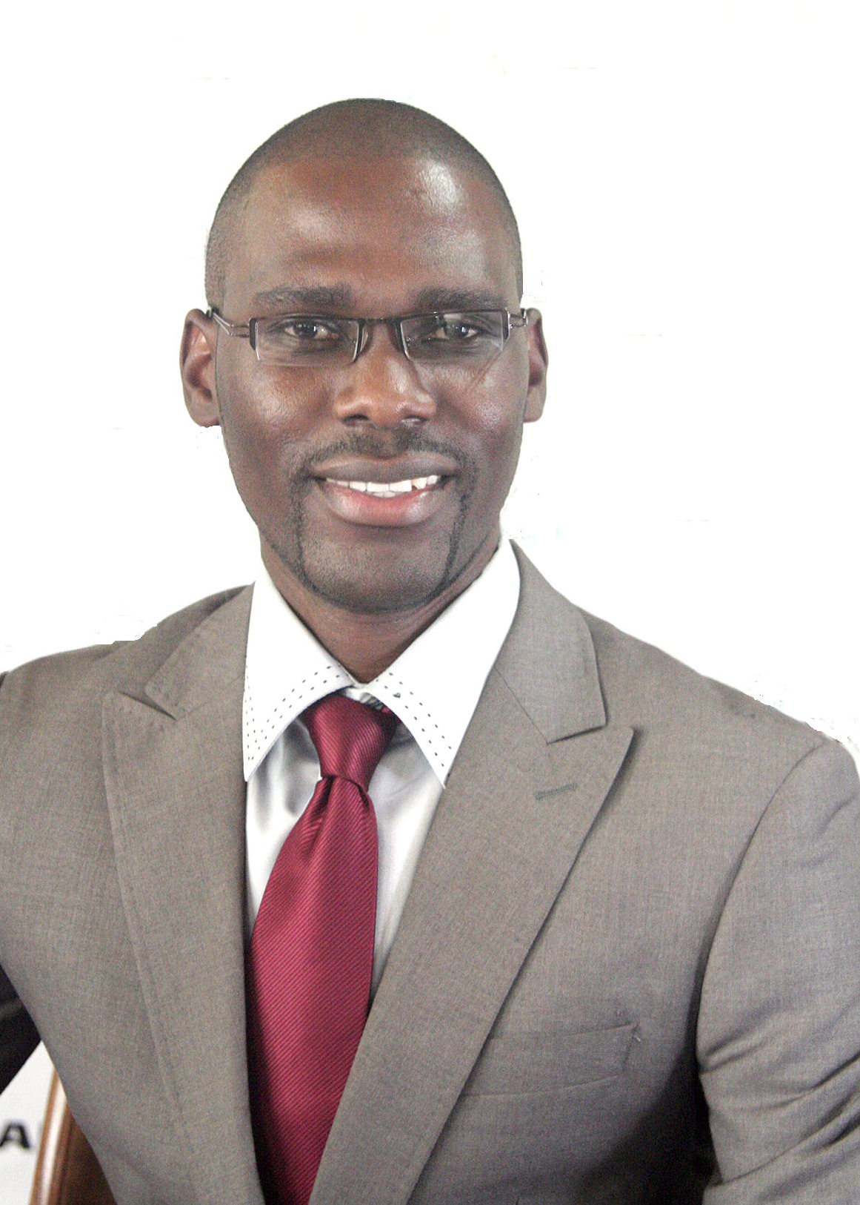
I am a qualified Accounts person with a Diploma in Accounting, Bachelor in Business Administration. I have considerable experience in Finance. I am a 31 year old male who prides in attending to all duties and tasks assigned in a professional and diligent manner. I mix well with other colleagues and I also adapt easily to new environments. I communicate well at all levels.
SUMMARY:
WORK EXPERIENCE:

LAFARGE CEMENT ZIMBABWE –Accounting Assistant Treasury
NOVEMBER 2010 – TO DATE

RESPONSIBILITIES lNCLUDE
- General Ledger maintenance
- Cash Book maintenance
- Assisting with budgeting and forecasting
- Management of P&L sheet for the business unit
- Management and commentary on the various cost centers
- Cash flow reporting
- Month end close and all associated reconciliations.
- Cash flow Management

Accounts Payables Supervisor
Period: July 2007 – Nov 2010

- Coordinates daily workflow to ensure timely preparation and approval of payment disbursement.
- Coordinates, recommends, and implements processes and internal controls
- Develops and plans section training and projects
- Ensures that invoices and expenses are processed accurately and timely
- Reconciling clearing accounts
- Coordinates with other departmental divisions to ensure timely payment of invoices and expenses.

Credit Controller (Accounts Receivable)
- Review the company credit control procedure and develop and implement enhancements where required.
- To manage the outstanding sales balances falling due and contact customers before the balances become overdue to confirm payments.
- Set and monitor credit limits.
- Assist in developing and implementing a Direct Debit payment system.
- Where required initiate proceedings to ensure outstanding debts are bought to a satisfactory conclusion.
- To keep the company up to date with new credit management procedures and techniques.

PROFESSIONAL QUALIFICATIONS

SAAA 3RD level Group Diploma in Accounting
Bachelor in Business Administration Degree (MANCOSA)

CURRENT STUDIES
Association of Chartered Certified Accountants

ORDINARY LEVEL CERTIFICATE

Five Ordinary level passes

·Date of Birth : 18 September 1984
PERSONAL
DETAILS:

·Nationality : Zimbabwean

·

LANGUAGE  LANGUAGES: | READ | SPEAK
English | Fluent | Fluent

Personal Attributes

Enjoys pulling together of resources as a team

Able to interact at all levels

Able to work effectively with minimum supervision

Able to work under pressure and meet deadlines

Expertise spans all facets of banking, finance, administration and operation management within major corporations

Strong organizational and planning skills

Motivated and strong drive to succeed

Exceptionally organized and resourceful, with wide range of skills

Reliable and adaptable; learn new systems quickly and take initiative

Systems and Applications

Used Excel and Access for spreadsheets, and database records.

Used dBase to design custom screens, generate reports, and design menus.

Used Microsoft Word to generate correspondences and reports

Generated financial statements and general ledger, using Sun systems V

Qualified and comfortable to use Pastel Accounting, Sage line 1000, Sage X3

