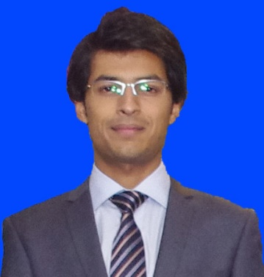
ARSLAN
ARSLAN.244533@2freemail.com
Electronics Engineer
.

Career Objective
To gain employment in a reputed and progressive industry where my abilities and skills would be an asset and to utilize my knowledge in practical way.
Academic Qualifications
B.Sc. (Electronics Engineering)  2011-2015 | University of Engineering & Technology, Taxila | CGPA: (3.00/4.00)
F. Sc. (Pre-Engineering)  2009-2011 | Punjab College of IT, Rawalpindi | 80.63% (887/1100)
Matriculation (Science)  2007-2009 | Sir Syed Public School, Rawalpindi | 88.3% (928/1050)
Experience
Internship at PTCL H-9, Islamabad 6 Weeks (30th June 2014 – 8th Aug 2014)
Certifications
Siemens PLC, HMI & SCADA 2 Weeks (19th Oct 2015 – 30th Oct 2015)
Projects
      - Analog to Digital Convertor
      - C++ Based Educational Institute Login System
      - Sensor Counter Using Phototransistor
      - RPM Counter
      - Design of 32 bit Single Cycle MIPS (RISC) Processor in Verilog
      - LCD based Digital Alarm clock
      - Digital Clock Based on FPGA
      - Load Management & GSM based Electricity Energy Meter Billing
Skills
- Good Communication Skills
- Leadership Skills
- Presentation Skills
- Working in Group
Computer Skills
- Working diligently towards the enhancing command on

- MS Office  - MATLAB | - Visual Studio C++  - Modelsim | - AutoCad  - Proteus
- OrCAD | - Xilinix
Sports & Activities

- Cricket | - Football | - Table Tennis
References
- Will be furnished on demand.

