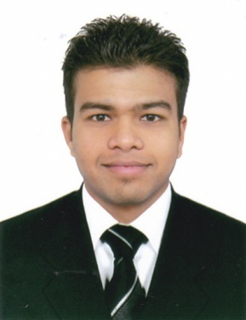

Dhanraj
EMAIL ID: 244597@gulfjobseekers.com

PROFESSIONAL PROFILE

To work in highly challenging and competitive environment for the enhancement of my creative abilities and optimum profitability of the organization, to make a significant contribution to the community by involving people who can and have the value resources to contribute.

SKILLS
- Communication Skills
- Perform well under pressure
- Mature, Positive and professional attitude
- Identify and solved problems to satisfaction of all concerned
- Open to new ideas and work well with others
- Dependable and Trustworthy
- Responsible, Competitive, Flexible and can work under minimum supervision
EDUCATIONAL ATTAINMENT

- Under Graduate
- 1 year Diploma in Hotel management with HRDF certificate.
WORKING EXPERIENCE

COMPANY : Vetra Investment LLC (Baja fresh Mexican grill)
POSITION : Shift leader
YEAR : 2011 to Present

PREVIOUS WORK EXPERIENCE

Work as commii in Hacienda de Goa resort in 2010 till 2011.

DUTIES AND RESPONSIBILITIES

- Assisting customers in selecting and locating the right product is vital to ensuring that the customer is satisfied as completes the transaction.
- Communicating with customers is a broad category that includes welcoming customers, assessing the customer's needs and answering any questions that the customer may have.
- Work with clients to create various looks.
- The set target on a monthly basis, allotted for each counter staff is achieved with a motive as a customer satisfaction and the company profit too.

EXTRA SKILLS:
- Computer Basics at NIIT
- Attended customer Service work shop

PERSONAL INFORMATION

NATIONALITY : India (Goa)
BIRTH DATE : 16/12/1990
MARITAL STATUS : Single
LANGUAGES : English, Hindi, Marathi, Konkani
VISA STATUS : Employment Visa

HOBBIES:
Sports, music, traveling, reading books
I hereby declare that the information given is correct to the best of my knowledge and that I have not with held any information which may affect my suitability for employment.
Dhanraj
Applicant

