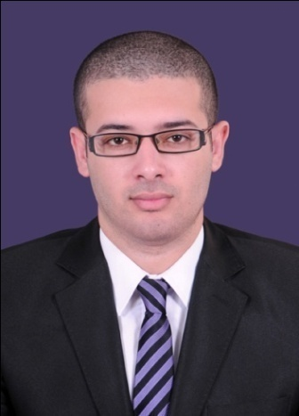
Nassar
Structural Engineer
Nassar.244666@2freemail.com
▪ Objective Seeking a position as a structural design engineer.
▪ Personal Info.
- Date of Birth : 04/08/1990
- Marital Status : Single
- Nationality : Egyptian (current location)
- Military Status : Completed military service
▪ Contact Info.
- Mobile number : C/o 971501685421
▪ Education
Bachelor’s degree in Civil Engineering, Cairo University, Faculty of engineering, 2013.
- Cumulative grade : Good
- Senior year grade : Very Good
- Graduation Project : Structural Analysis project – High rise RC buildings
- Grad. Project grade : Excellent
▪ Languages
Arabic: Native Language.
English: Excellent.
▪ Computer Skills
SAP 2000 – AutoCAD 2D – ETABS – SAFE – CSI Column – Microsoft Office Package
▪ Experience
Work Distance Studio Consultants (DSC) Senior Structural Shop Drawing Engineer
(April 217 – Present)
Coordinate structural design with other relevant disciplines and produce structural
shop drawings based on design drawings.
Kafrawy Consulting Engineering Group (KCEG) Structural Design Engineer
(March 2015 – April 2017)
Perform structural analysis and design for different types of reinforced concrete structures.
Produce structural shop drawings based on design drawings. Prepare B.O.Qs.
Egyptian Armed Forces Consulting Structural Engineer (March 2014 – March 2015)
Supervise and appraise the construction process of the social housing project in
6th of October city funded by the UAE. Make sure the construction process is completed
according to prepared plans and drawings in addition to meeting the safety and quality
standards.
Multiple freelance RC design and shop drawing projects.

Training Arab Contractors Civil Engineer Trainee (summer 2011)
Ring road extension at “Imbaba Airport” site.
El-Banna Contractors Civil Engineer Trainee (summer 2012)
Regional headquarters of UNESCO project in 6th of October city.

