

Gulfjobseeker.com CV No: 1468194

Mobile +971504753686, +971505905010
cvdatabase[@]gulfjobseeker.com
To contact this candidate use this link
http://www.gulfjobseeker.com/feedback/contactjs.php

WORK EXPERIENCES
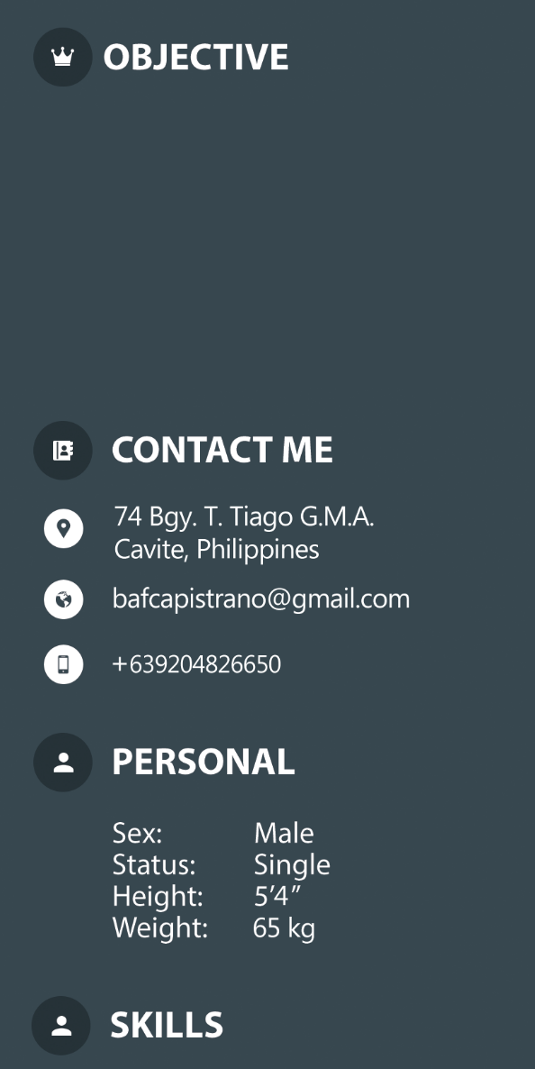
To be a part of an esteem organization wherein my capabilities can grow and to enhance my skills in a dynamic and fast paced work place, seeking for a responsible job with an opportunity for a profession challenges.

Sex: Male
Status: Single
Height: 5’4’’
Weight: 65 kg

FIELD SERVICE TECHNICIAN
DEFENSE AND PROTECTION SYSTEMS PHILS, INC.
MAY 2015 – PRESENT
- Serves clients by installing and servicing products such as Conventional X-ray Systems, Walkthrough metal detectors and Full body scanners all over the Philippines.
- Maintains rapport with clients by examining complaints; identifying solutions; suggesting improved methods and techniques; recommending system improvements.
- Keeps equipment operating by following operating instructions; troubleshooting breakdowns; maintaining supplies; performing preventive maintenance; calling for repairs.
- Documents service and installation actions by completing forms, reports, logs, and records.
IT STAFF (On the Job Training)
LOCAL GOVERNMENT UNIT – GMA, CAVITE
APRIL 2014 – JUNE 2014
- Developing software to help Municipality on their transactions.
- Designing tarpaulins for announcements and community projects.
- Installing and configuring computer hardware, operating systems, and applications.
- Monitoring computer systems and networks.
- Talking to staff regarding their queries either face to face or over the telephone to help set up systems or resolve computer issues.
- Troubleshooting system and network problems, diagnosing and solving hardware/software faults.
- Replacing parts as required.


EDUCATION
- Software Development using VB.NET and C# with Database like MySQL and MS SQL
- Computer troubleshooting and networking
- Literate in Adobe Photoshop and Illustrator
- Literate in Adobe Audition
- Knowledge in Microsoft Office
BACHELOR OF SCIENCE IN INFORMATION TECHNOLOGY

CAVITE STATE UNIVERSITY- CARMONA CAMPUS
APRIL 2015

