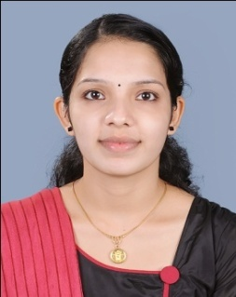
Objective
To strongly contribute the best of my skills and abilities in the domains of both evaluation and habilitation/ rehabilitation of population with hearing, speech and language impairments, committed to provide service and relish challenges with Determination, Devotion and Discipline.

Clinical Experience

PERIOD | POSITION | ORGANIZATION
August 2012 - August 2014 | Speech Therapist & Audiologist | Recoup Group Of Clinics, Neuromusculoskeletal Rehabilitation Centre, Kerala, India
August 2014 - Present | Speech and Language Pathologist | Alia For Early Intervention,  Bahrain

Qualification Summary

INSTITUTION | QUALIFICATION | YEAR OF PASSING
National Institute of Speech & Hearing, Kerala University, India. | Bachelor of Audiology & Speech Language Pathology | 2012
Govt. Girls HSS | Higher Secondary Education | 2008
CNN GHSS, CHERPU | Secondary School Level Certificate | 2006

Internship

During the final year of my Bachelors' Programs I have worked as a clinician under supervision, assessing and treating wide variety of clinical populations, in the domains of both Speech-Language pathology as well as Audiology.

HOSPITAL | PERIOD
NIMHANS, BANGALORE | JUNE 2011-JULY 2011
SPASTIC SOCIETY OF TAMILNADU | AUG 2011-SEP 2011
NATIONAL INSTITUTE OF SPEECH AND HEARING(NISH) | NOV 2011, JAN – MARCH 2012
SANTHWANA ENT HOSPITAL | OCT 2011
KERALA INSTITUTE OF MEDICAL SCIENCES  (KIMS) | DEC 2012

Scientific Conferences Attended

- ISHACON 42 , Bangalore (2010)
- 1st PAED.AUD.CON 2010, Alappuzha.
- Strategic management of swallowing disorders; NISH, Trivandrum

Specialized skills and traits

- Working with people from various disciplines
- Experience in working with autistic spectrum disorders
- Strong interpersonal skills
- Strong team player with leadership qualities
- Self motivated
- Quick mingling with children

PERSONAL PROFILE

Gender | Female
Nationality | Indian
Marital status | Married
DOB | 11/04/1990

Gulfjobseeker.com CV No: 1468878

