Gulfjobseeker.com CV No:1470510
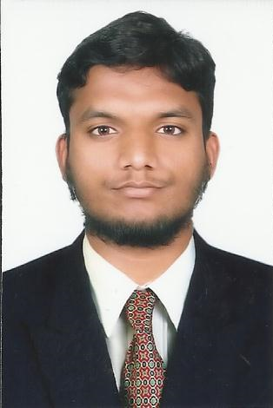Mobile +971504753686, +971505905010
cvdatabase[@]gulfjobseeker.com
To contact this candidate use this link
http://www.gulfjobseeker.com/feedback/contactjs.php
Designation: CIVIL DRAFTSMAN

CAREER OBJECTIVE:

To associate with an esteemed organization that provides me an opportunity to show my skills, improve my ken with latest trends and to be a part of the team that works dynamically towards the growth of the organization.

EXPERIENCE:
M/S: P.PENTAIAH & SON’S, HYDERABAD, INDIA
(Jan 2011 – August 2015) (Civil Draftsman & Interior Designer)
Key Responsibilities:

- To prepare and supervise the drawings of all the Civil Construction Works using Auto CAD.
- To Modify the Shop Drawings on time and under Quality parameters fixed by Team Leader as per the comments of client & consultant.
- To prepare the As Built drawings as per the site conditions after completion of works.
- Fulfil weekly targets fixed by the team leader.
- To prepare the External Elevations and Interiors design Drawings, Including reflected Ceiling Plans as per the tender drawings, consultant & client requirements.
- Preparation of Civil / Architectural Drawing Plans, Elevation and Sections in Auto CAD.
- Preparing the proposed drawings, fit out plans, reflected ceiling layouts & power layouts.
- Preparing all the drawings for municipality submission & approval.
- Preparing of Floor patterns and their cut list of Carpets, Marbles and Stones etc.
- Building Designing, Walk through, & attractive perspective views in 3DS’MAX.
- Preparation of 3D Solid Modelling, reflective Vray views & editing in Photoshop.
Page: 1 / 2
PROjects PROFILE:
S.No NO. | PROJECT TITLE | CLIENT | CONSULTANT | LOCATION
1 | Gowtham modal high school at Hyderabad  ( G+4) | M/s: MAQDOOM AIL & SON’S | M/S: P.PENTAIAH & SON’S | Hyderabad,  India.
2 | Apoorva Hospital  At Hyderabad  (G+3) | M/s: Dr.ARJUN.E | M/S: P.PENTAIAH & SON’S | Hyderabad,  India.
3 | Aries Meternity  Hospital at Hyderabad (G+3) | M/s: Dr.SEEMA GAUR. | M/S: P.PENTAIAH & SON’S | Hyderabad,  India.
4 | Challa Eye Care Hospital  At Hyderabad (G+4) | M/s: Dr.RAVI PRASAD CHALLA. | M/S: P.PENTAIAH & SON’S | Hyderabad,  India.
5 | Amrutha Tiffin Hotal  at Hyderabad (G+3 | M/s: ASHOK SHETTY | M/S: P.PENTAIAH & SON’S | Hyderabad,  India.

PROFESSIONAL PROFILE:
- Technical Qualification : Diploma in Architectural Designing, (In Sep.2008)
@ M/S. Remax Architects & Engineers Academy.
- Software’s : Auto cad, 3DS’MAX, Vray, Adobe Photoshop.
: Basic Computer, Window XP, Window 7.
: MS - Office
- Academic Qualification : Secondary School Certificate.

PERSONAL PROFILE:
Date of Birth : 20th October, 1994.
Nationality : Indian.
Languages Known : English, Telugu, Urdu & Hindi.

Page: 2/2

