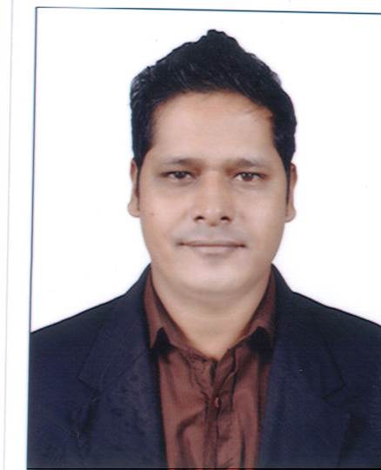
James
James.246143@2freemail.com
______________________________________________________________________________________________

CAREER OBJECTIVES :

To succeed in an environment of growth and excellence and earn a job which provides me job Satisfaction and self-development and help me achieve personal as well as organization goals.

WORK EXPERIENCE :

Working at SANJAY DUTT PRODUCTION PVT LTD AS “ADMIN OFFICE MANAGER”
From August 2012 till date

Job Responsibilities:

- Resolves administrative problem by coordinating preparation of reports, analyzing data and identifying solution.
- Maintaining vendor bill and following up with the accounts department for payment process.
- Ensures operation of equipment by completing preventive maintenance requirement; calling for repairs; maintaining equipment inventories; evaluating new equipment and techniques.
- Preparing duty roaster for office boys and updating attendance and leave on monthly basic.
- Handling printing & stationery and housekeeping service.
- Checking maintenance issue and functioning and resolving the matter at earliest.
- Maintains supplies inventory by checking stock to determine inventory level; anticipating needed supplies; placing and expediting orders for supplies; verifying receipt of supplies.
- Contributing to team effort by accomplishing related result as needed.

Worked for RELIANCE MEDIAWORKS LTD AS A “ADMIN EXECUTIVE”
From July 2009 till June 2012

Job Responsibilities:

- Keeping track attendance and sending to HR team and track of travelling bill, food bills and other expensed of employees on excel sheet.
- Maintaining vendor bill and following up with the account dept for payment process.
- Resolves administrative problem by coordinating preparation of reports, analyzing data and identifying solution.
- Ensures operation of equipment by completing preventive maintenance requirement; calling for repairs; maintaining equipment inventories; evaluating new equipment and techniques.
- Checking maintenance issue and functioning and resolving the matter at earliest.
- Maintains supplies inventory by checking stock to determine inventory level; anticipating needed supplies; placing and expediting orders for supplies; verifying receipt of supplies.
- Hotel room booking for clients coming from different state and country to work on various films.
- Handling housekeeping, printing & stationery, front desk, PRO catering service.
- Completes operational requirements by scheduling and assigning administrative projects; expediting work result.
- Preparing duty roaster for office boys and updating overtime on monthly basic.
- Contributes to team effort by accomplishing related result as needed.

Worked for ZENTA PVT LTD AS A “CUSTOMER RELATION ASSOCIATE”
From December 2007 to February 2009

Job Responsibilities:

- Collection on bank credit cards which is due to be paid for many years.
- Following with the debtors on payment of credit cards bills and also making them aware of their credit report.
- Updating the status of the payment on daily reports.

Worked for BARISTA COFFEE LTD AS A “GUEST EXPERIENCE MANAGER”
From June2007 to December2007

Job Responsibilities

- Handling cash counter, Preparing daily stock inventory, cash inventory.
- Banking daily sales and updating the sales and daily inventory by mail to the manager.
- Encouraging staff to achieve daily sales target and maintaining hygiene check and café cleanliness.

Worked for MUFFIN BREAK FU REP INTL AT DUBAI AS A “SUPERVISOR”
From February2005 to November2006

Job Responsibilities:

- Handling customer service and convincing them to order different product of coffee and muffins.
- Handling cash counter, ordering daily stock as per café requirement.
- Preparing duty roaster of the staff.
- Encouraging staff to achieve daily sales target and maintaining hygiene check and café cleanliness.

Worked for CAFÉ COFFEE DAY AS A “OPERATIONAL TRAINEE”
From December2002 to May 2004

Job Responsibilities

- Handling cash counter taking orders.
- Training staff on preparation of different beverages.
- Achieving daily and monthly sales target.
- Encouraging staff to achieve daily sales target and maintaining hygiene check and café cleanliness.

Worked for WATER KINGDOM AS A “CUSTOMER SERVICE EXECUTIVE”
From February2001 to November2002

Job Responsibilities:

- Handling cash counter taking order of guest.
- Handling customer complains in terms of lost items.
- Preparing daily stock inventory, cash inventory.
- Depositing cash sales in the treasury.

EDUCATIONAL QULIFICATION:

Education | Year | Board
B.A (Public Administration) | 2013 | Mumbai
H.S.C | 2000 | Mumbai
S.S.C | 1998 | Mumbai

PROFESSIONAL QULIFICATION:

Basic knowledge about computer
Microsoft Excel, Microsoft Word, Power Point and MIS reports.

PERSONAL DETAILS:

Languages Known` : English, Hindi, Marathi, Konkani
Date of Birth : 27TH July, 1980
Marital Status : Married
Nationality : Indian
Religion : Roman Catholic
Visit Status : Visit Visa
HOBBIES : Listening Music, Playing Football, Cricket

