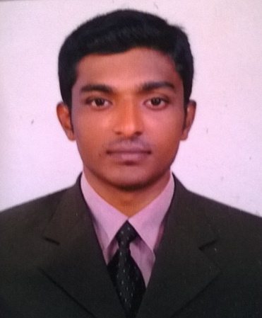 | Riju  Riju.246481@2freemail.com  Career Objective  To be a part of an organization which uses my skills and expertise, in its process of growth and changes while giving me opportunities to learn and enrich my skills and competencies in the area of information technology industry  Professional experience: 5 years and 3 month  Previous company : INTARVO TECHNOLOIES LIMITED  - Two year experience in Laptop and Desktop and Server Servicing Engineer [INTARVO TECHNOLOIES LIMITED, Bangalore, India]  Duration :September 2013 to August 2015  Roles:-  - Data backup and mail backup  - IP phone and printer configuring and maintaining  - Software and Anti-Virus updating and maintaining  - Configuring Remote Desk toping  - Handling of help desk support remote control of end-users/remote users computer/Laptop to troubleshoot, diagnose and resolve complex issues by using remote tools, such as Team Viewer, Microsoft Remote Desktop  - Desktop, laptop and monitor data wiping and function test  - Desktop, laptop and monitor troubleshooting and repairing  - Install, configure and upgrade pc software and operating system  - Configure, Maintain of internal computer network
- Two Year experience in Desktop Servicing Engineer [Infoway Computers, Mathikare Bangalore, India]
Duration: May 2011 to August 2013
Roles:-
- Software and Anti-Virus updating and maintaining
- Configuring Remote Desk toping
- Handling of help desk support remote control of end-users/remote users computer/Laptop to troubleshoot, diagnose and resolve complex issues by using remote tools, such as Team Viewer, Microsoft Remote Desktop
- Desktop, laptop and monitor troubleshooting and repairing
- Install, configure and upgrade pc software and operating system
- Configure, Maintain of internal computer network

- One Year experience in call center [Vodafone Retailer Desk, Cochin, India]
Duration: May 2010 to March 2011

Awards and Achievements
- Awarded with a Trophy” EMPLOYEE of the MONTH” in Tarvo Technologies Ltd.

Academic Profile
Course | Board\University | Institution | Year of pass out
Diploma in Computer Engineering | Board of technical examination | Govt, Polytechnic, vechoochira, Kerala, India | 2010
HSC | Hse Board, Kerala | Mphss,Pathanamthitta, Kerala, India | 2007
SSLC | General Education Department, Kerala | Rvhss, Konni, Kerala, India | 2005
Personal details
Nationality : Indian
Gender : Male
Date of Birth : 25-09-1990
Age : 25
Marital Status : Single
Valid Driving License : India

Professional Skills
Comprehensive problem solving abilities, excellent verbal and written communication
Skills, ability to deal with diplomatically , willingness to teach team facilitator and hard worker.

Languages

I Read : English, Malayalam and Hindi
I Write : English, Malayalam and Hindi
I Speak : English, Malayalam, Tamil, Hindi and Kannada

Technical Exposure

Technical Knowledge : Desktop , Laptop , Monitor & Server repairing .Wiping &Testing
Languages knows :C, C++ and java
Operating System : Windows 7, Windows 8.1 XP, Vista.
Office Tools : MS Office 2003, 2007, 2010 and Dos
Web Designing :HTML

Extra Curricular

Player of school and college foot ball team and cricket team.
Event organizer in all school and college annual day functions and other technical events.

Hobbies

Learning, browsing, reading and listening music

Declaration

I hereby declare that the above furnished information is true to the best of my knowledge.

