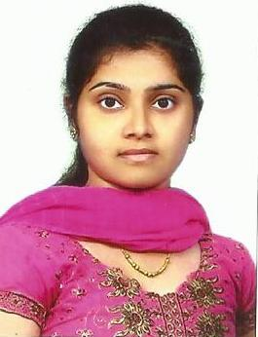
CURRICULAM VITAE

Email : 246656@gulfjobseekers.com

CAREER OBJECTIVE:

I am seeking to a part of a growing organization with challenging work environment , offering a chance to excel in personal and team work achievements. My endeavor and dedication in the job will be helpful in achieving the company’s goals and objectives.

WORK EXPERIENCE:

At present I am working with M/s. Glitzma Technologies Pvt. Limited ,Pandalam, Kerala , India as a Junior Software Engineer from August 2014 onwards.

JOB DESCRIPTION:

- Coding of forms and designing.
- Testing programs and fault findings.

TECHNICAL SKILL:

- Languages : C# , SQL
- Database : SQL Server 2005, SQL Server 2008
- Technology : C#.NET, ASP.NET

PROJECT WORKS :

- CostCS:

This WINDOWS based on project billing application which facilitates the automation of an old age home, mainly intends for controlling Cost.

TECHNOLOGIES USED :

C#.Net, SQL Server 2008

Key Responsibilities: Design, Coding Forms , Manual Testing and Prepare Bug Report.

CLIENT: Travancore Foundation , Kottayam , Kerala, India.

- GiSchool:

This WINDOWS based on project facilities on automation of Schools, which is mainly involves the management of Examinations, Attendance and Timetables.

TECHNOLOGIES USED :

C#.Net, SQL Server 2008

Key Responsibilities :

Testing the Solutions and Preparing Bug Reports.

CLIENT: St. Nazreath English Medium School, Pathanamthitta, Kerala, India.

ACADEMIC PROJECTS :

STUDENT – STAFF INFORMATION SYSTEM

A web based application that automates all information of students and staffs in the School.

TECHNOLOGIES USED : ASP.NET, SQL.

EDUCATATIONAL QUALIFICATIONS:

Course | University/ Board | Year | Percentage
B E in Computer  Science Engineering | Anna University  Chennai , India | 2013 | 72
Higher Secondary | HSE Board of Kerala,India | 2008 | 68
S S L C | CBSE , New Delhi,India | 2006 | 58

PROFESSIONAL COURSES:

I have done six months Bank Probationery Officer Coaching Course in ICD , Kollam, Kerala, India.( 2013 – 2014 )

I have done three months ASP.NET Certification ( Rajiv Gandhi Education Foundation ) Course in Cybex , Adoor, Kerala , India.

EXPOSURES:

Operating System : Windows7, Windows XP
Office Suit : Microsoft Office

PERSONAL DETAILS :

Nationality : Indian

Sex : Female

Marital Status : Single

Religion : Christian

Language Known : English , Malayalam , Tamil

Driving License : Valid Indian Driving License

Hobbies : Gardening , Playing Chess( Champion in
Inter College Competition )& Puzzles

Availability : Immediate

