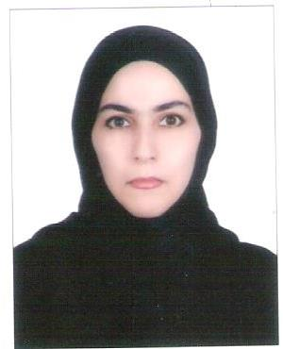
Pharmacist
Ayeh
Ayeh.246783@2freemail.com

- Nationality : Iranian
- Marital Status : single
- Driving License : Valid Iranian License
OBJECTICE:
To pursue a challenging career in a prestigious organization having attractive working environment, prospects of learning and growth, in line with educational qualifications, skill, proficiency and experience and to utilize my capabilities to the fullest to improve and excel.
EDUCATION:
B.se.Pharmacy
College of pharmacy and health science, Ajman University of Science and technology, Ajman-UAE Jan2012
B.Sciences:
Islamic Azad University,Agricultural Engineering-Agronomy and plant breeding Tehran-Iran 2004
Training Courses:
A-Clinical pharmacy training course,GMC Hospital Fujairah.
COMPUTER SKILLS:
Words,Power Point,Excel,Internet ---------Etc
COMMUNICATION/PRESENTATION SKILLS:
Effective and efficient writing skills,oral communication skills and listening skills.
- Iranian- Mother Language
- English
- Arabic
- Turkish
COFERENCES:
- Dubai international pharmaceutical & technologies conference and exhibition Duphat 2012 Dubai. UAE, March 2007
- Dubai international pharmaceutical & technologies conference and exhibition Duphat 2012 Dubai. UAE, March 2008
- Dubai international pharmaceutical & technologies conference and exhibition Duphat 2012 Dubai. UAE, March 2009
- Dubai international pharmaceutical & technologies conference and exhibition Duphat 2012 Dubai. UAE, March 2010
- Dubai international pharmaceutical & technologies conference and exhibition Duphat 2012 Dubai. UAE, March 2011, to 2015-07-11

COMMITTEE:
- Member of Iranian Agricultural association committee,2006-now
- Member of Iranian Agricultural association committee, Ajman University,2007-2011
- Member of Social committee, Ajman university,2006-2011
TRAINING COURSES:
Community pharmacy 1. Fujairah pharmacy, Fujairah, UAE.
Community pharmacy 11. Fujairah pharmacy, Fujairah, UAE.
Hospital pharmacy training 1 & 11.GMC Hospital Fujairah,UAE.
Pharmaceutical technology training .Julhar pharmaceutical Company RAK, UAE with excellent grage.
Clinical pharmacy training Course, Iranian, Jan 2012-Now
EXPERIENCE:
Dec 2007-April 2012
Trainer as pharmacist, Bander Inzali pharmacy, Iran During summer vacations.
2012-2014
As a Pharmacist in Pharmacy, Iran 2015
Life pharmacy-Dubai

