Gulfjobseeker.com CV No: 1481268
Mobile +971504753686, +971505905010
cvdatabase[@]gulfjobseeker.com
To contact this candidate use this link
http://www.gulfjobseeker.com/feedback/contactjs.php
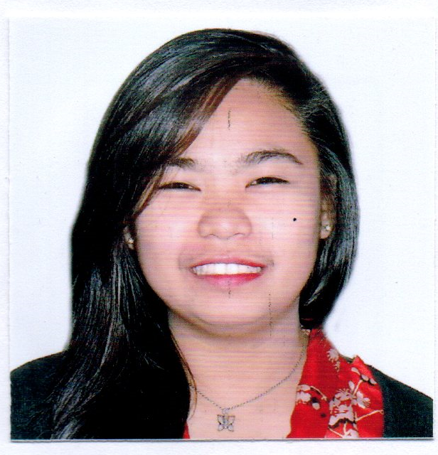

PERSONAL INFORMATION
Age: 19 years old
Sex: Female
Language: Tagalog/English
Civil Status: Single
Birthday: May 17, 1996

CAREER OBJECTIVE:

To enhance my knowledge and gives the loyalty to the company, explore my ability in terms of job descriptions. I want to succeed in a simulating and challenging environment that will provide me with advancement opportunities.

EDUCATION

College Business Administration
Major in Computer Secretarial
Access Computer College
2013-2015

SKILLS SUMMARY

- Good knowledge in English – reading, written and spoken
- Good communication skills
- Highly organized and dedicated with positive attitude.
- Proficient in Microsoft Office Application.
- In-depth receptionist skills.
- Effective and flexible in dealing with different people
- Professional in appearance and presentation.
- Able to multi-task effectively and prioritize demanding workflow.

Work and Training Experience:

Chauffeur Car Rental
Secretary and Admin Fleet Officer - Doha Qatar
August 1, 2015 to present

- Maintain the arrangement and the cleanliness of the area.
- To provide General office assistance such as Photocopying, Scan, fax, and print documents.
- Filing of documents
- Arranging of the meeting room
- Overall in charge of Administrative Works.
- Helping and assisting Accounts Department
- Making Timesheets for drivers.
- Doing administrative reports for the General Manager.
.
Syscoms Information Technology
Training in Doha Qatar

- Receive and transfer phone calls, take messages and direct where appropriate, greet and assist walk in-people.
- Overall in charge of Administrative Works.
CAA Construction Company
Receptionist / Secretary

Job Responsibilities:

- Receive and transfer phone calls, take messages and direct where appropriate, greet and assist walk in-people.
- Maintain the arrangement and the cleanliness of the Reception area.
- To provide General office assistance such as Photocopying, Scan, fax, and print documents.
- Filing of documents
- Arranging of the meeting room
- Overall in charge of Administrative Works.

Saint Jude Quasi Parish
Assistant / Secretary (On the Job Training)

Job Responsibilities:

- Filing of documents
- Preparing materials for the events.
- Coordinating and arranging meetings

