CURRICULUM VITAE

ALIYA
ALIYA.247406@2freemail.com
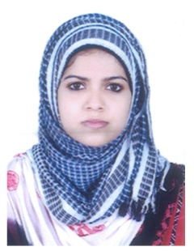

CAREER OBJECTIVE

To work in a firm with a professional work driven environment where I can utilize and apply my knowledge, skills which would enable me to grow while fulfilling organizational goals.

ACADEMIC QUALIFICATIONS
Course | Name of The Institution | Board/University | Year of Passing | Percentage
M.E in POWER AND ENERGY SYSTEMS | University Visveswaraya collage of Engineering.Banglore | Bangalore university | Pursuing,  Anticipated date of Graduation December-15 | 81%(Average of three semesters)
AMIE in Electrical and Electronics Engineering | Visveswaraya Institute of Engineering Technology , Kottayam | The Institution of Engineers(INDIA) | 2013 | 8.71(CGPA)
CLASS XII | St.Gemma’s G.H.S.S Malappuram | Kerala HSE Board | 2009 | 92.83%
SSLC | St.Gemma’s G.H.S.S. Malappuram | Kerala State Board | 2007 | 95%

COMPUTER SKILLS

- Mi Power, MATLAB (Power system softwares)
- RT-LAB, HYPERSIM (Real time Softwares)
- Other (MS tools)

AREA OF INTEREST

- Economic Dispatch,Optimisation,Smart Grid, Load Flow

ACADEMIC PROJECT AND SEMINAR DETAILS

- Project on “A Novel Algorithm for Intelligent Home Energy Management”.
- Built exciter library for HYPERSIM software as a part of internship.
- A mini-project on “Development of a controller for economic load dispatch by generating units under varying load demands”.
- A project on “Capacitance Measurement and Significance of Power factor Improvement”.

WORKING EXPERIENCE
- Successfully completed 8 months internship in OPAL-RT TECHNOLOGIES. Worked on RT-LAB and HYPERSIM real time softwares. Worked in Electrical Modeling and Simulation team.

PERSONAL ATTRIBUTES

- Leadership skill
- Self-motivated
- Positive attitude
- Flexible
- Hard working

ACHIEVEMENTS

- Suman sarma [All India ladies second highest] award for AMIE Section -A.
- Associate Member in Institution of Engineers (India).
- Qualified GATE2013 with 88.31percentile.

DECLARATION

I ALIYA.P hereby declare that the above stated details are true to the best of my knowledge and belief.

