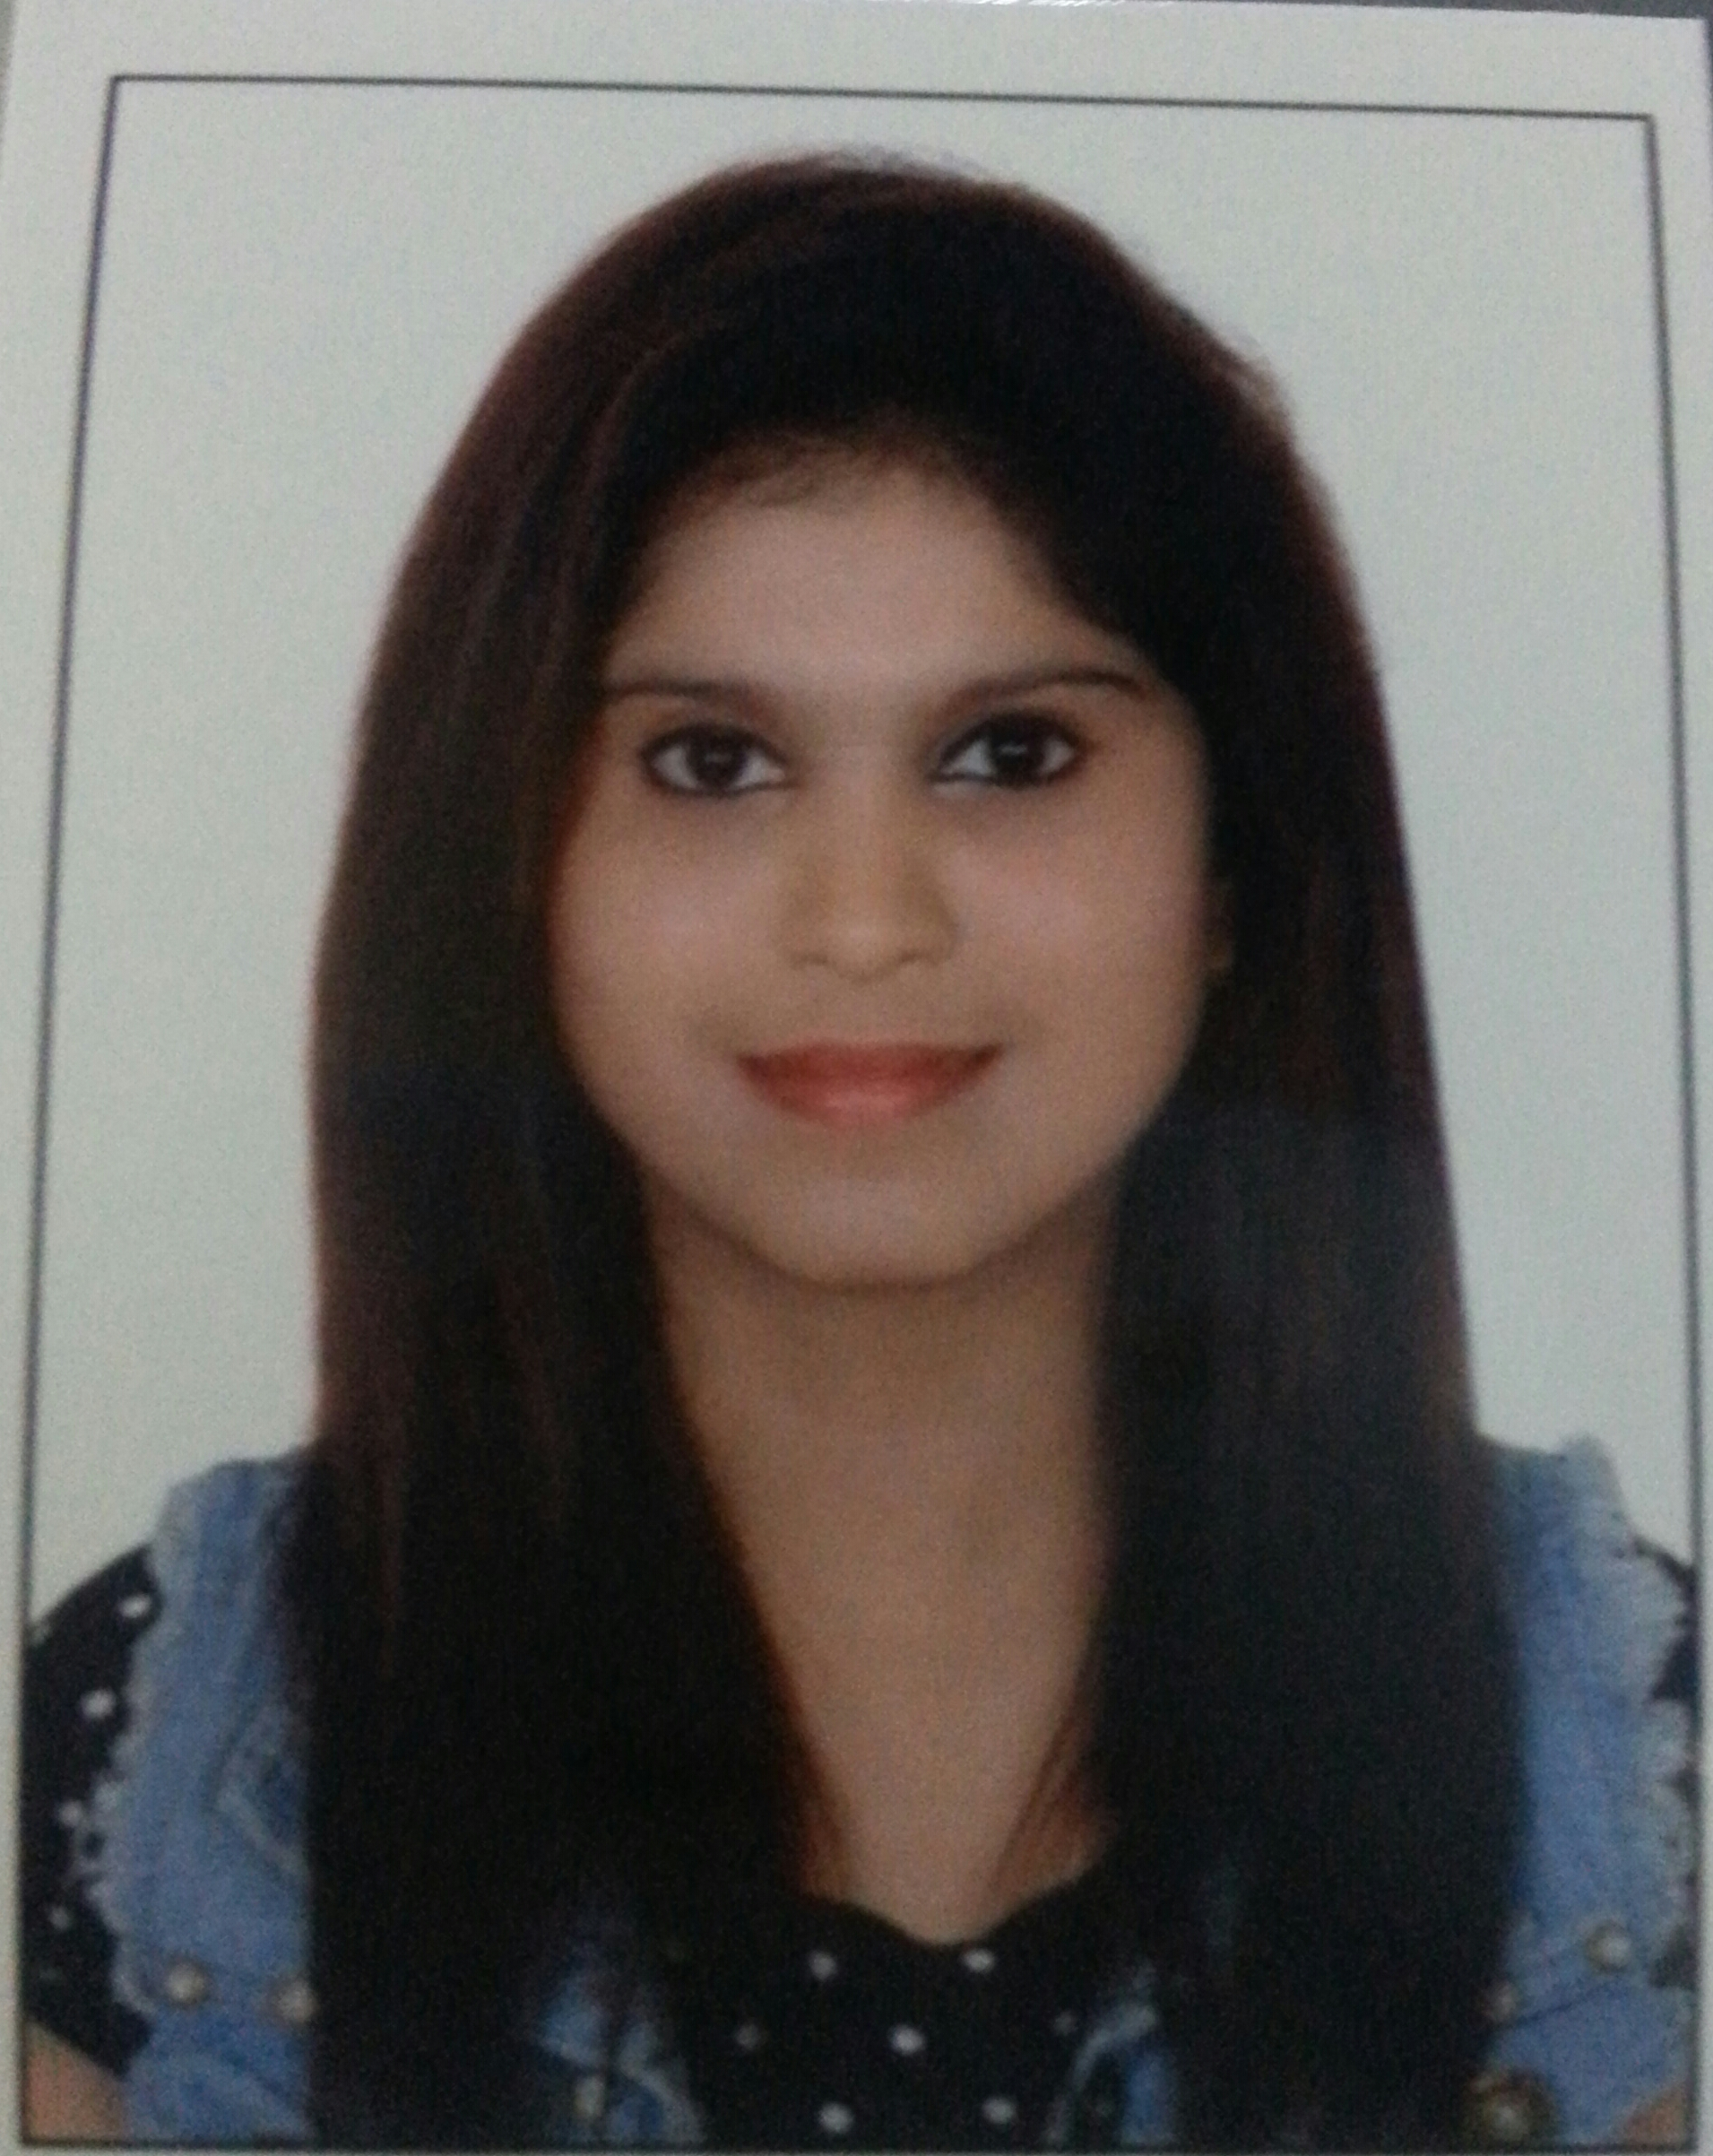

Deepali
Deepali.247625@2freemail.com

Professional Profile:

Seeking a challenging position with a progressive organization that will effectively utilize my knowledge and expertise, where i can go with the organization and prove to be an asset for its effective functioning, be a team player for the achievement of organizational goals and its success.

Educational Attainment:

  - School/College : Sydenham College Of Commerce $ Economics
  - Course/Degree : HSC Passed

Computer Skills:

    - MS office ( Word, Excel, Power Point)
    - Email $ Internet Explorer

Skills:

- Excellent customer service skills.
- Strong communication skills.
- High level of accuracy and attention to detail.
- Good organization skills.
- Good knowledge about customer service.
- Good time management skill

Working Experience:

Sales associate in UAE in landmark group from 2014 Dec – June 2015. CARPISA
- Ensure the highest standards of Visual Merchandise and housekeeping are maintained in store at all times.
- Provide the highest standard of customer service by demonstrating excellent knowledge of products and services.
- Attainment of desired target by concentrating on extraordinary brands.
- Cashier and responsible for handing in the Daily Sales Reports to the Head Office.
- Receiving the goods delivery and displaying them.
- Giving the store manager a report about the fast moving products.
- High lighting the Top 20 sold products.
- Checking the sold products for the section and the store
- Inventory control, Stock transfer in/out and maintain the back store in order to bring the smooth functioning of stocks.
- Replenishing and merchandising items effectively, displaying the product with correctly priced and optimizing sales in order to reach company’s budgets and meet the goals.

Professional Experience:

- worked with BHANSALI $ COMPANY for 2 years
- worked with DELLA TECNICA for 1 year

Duties And Responsibilities:

- Answer phones and operate a switchboard
- Route calls to specific people
- Answer inquiries about company
- Greet visitors warmly and make sure they are comfortable
- call persons waiting for visitors and book them a room to meet in.
- Schedule meetings and conference rooms.
- Ensure reception area is tidy.
- Coordinate mail flow in and out in office
- Coordinate office activities.
- Hand out employee applications.
- Send email and faxes.
- Perform basic book keeping ,filing and clerical duties

Personal Data:

- Date of Birth : August 21,1991
- Nationality : Indian
- Religion : Hindu
- Marital status : Single
- Languages :English, Hindi, Marathi

I hereby certify that the above information mention is true and correct to the best of my knowledge and belief.

