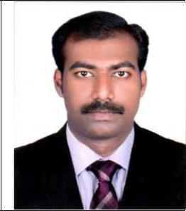

Curriculum Vitae

TANSON
TANSON.248100@2freemail.com

Objective:

To attain a challenging job in a suitable post where my dedication and hard work will gain a position of substantial responsibility and growth.

Academic Qualification:

Master Degree in Commerce from University of Kerala – 55% Bachelor Degree in Commerce from University of Kerala. – 69%

Higher Secondary Education from Higher Secondary Board, Kerala, India. – 79% Diploma in IATA/UFTAA FOUNDATION COURSE

Professional Qualification:

ICWAI From The Institute Of Cost Accountants Of India

Work Experience:

Worked as Cost Accountant Trainee at Kerala State Industrial Enterprises Ltd – 1 year

Areas of Experience:

  - Maintenance of Accounts in an ERP Environment

  - Preparation of various Schedules/Statements for periodic reconciliation, closing of accounts Etc

    - E-filing of Documents /Forms under Income Tax and Companies Act ,maintenance of Statutory books under companies act

Computer Knowledge:

Working knowledge in QuickBooks Working knowledge in MS- Office.

MS-Word, MS-Excel, MS PowerPoint Proficient in using Internet and Email. Working Knowledge in TALLY

Financial Auditing Computer Management From The Institute Of Cost Accountants OF India

Competencies:

Willingness to learn new concepts

Good leadership qualities and interpersonal skills Committed to deadlines and schedules

Systematic and hardworking

Personal Details:

⇒ Nationality | : | Indian.
⇒ Age | : | 25 yrs
⇒ Date of Birth | : | 27/09/1989.
⇒ Marital Status | : | Single.
⇒ Languages Known | : | English, Hindi and Malayalam.
⇒ Ability | : | can read, write and speak.

Declaration

I hereby declare that the information given above is true and correct to the best of my knowledge & all original certificates can be produced at the time of interview.

