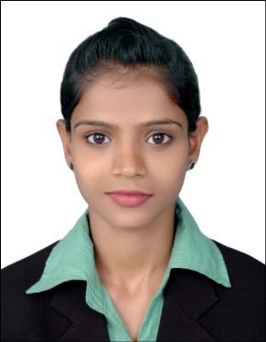
Kavita
E-mail: Kavita.248568@2freemail.com

CAREER OBJECTIVE

To secure a promising position that offers both a challenge and a good opportunity for growth, where I can

utilize and apply my knowledge, skills which would enable me to grow while fulfilling organizational

goals.

BASIC ACADEMIC CREDENTIALS

Qualification | Board/University | School/College | Year
F.Y.B.A. | Goa University | Govt. College - Goa | 2014 - 2015
H.S.C | Goa Board | Guardian Angel Higher | 2012 - 2014
 |  | Secondary School
S.S.L.C | Goa Board | Our Lady Mother of Poor | 2012
 |  | School

EXPERIENCE SUMMARY

Worked for M/S. Parodkar & Sons as a Sales Representative in their retail shop from Feb 2014 till date.

Responsibilities:

-Establishes. Develops and maintain business relationships with customers. -Process orders in person and over the phone

-Check inventory to ensure products is in stock -Collect method of payments and dispense change -Stock & organize shelves
-Ensure pricing is correct

IT PROFICIENCY

Microsoft Office Word, Microsoft Office Excel, Microsoft Office Power Point

Email & Internet application

EXTRA-CURRICULAR ACTIVITIES

Participated in cultural activities of the college and school.

PERSONAL DETAILS

Date of Birth | : | 12/04/1993
Nationality | : | Indian
Language known | : English, Hindi, Konkani, Marathi & Kannada
Hobbies | : | Singing, Gardening, Tailoring
Strength | : | Self confidence, Boldness, Positive approach.

