CURRICULUM VITAE

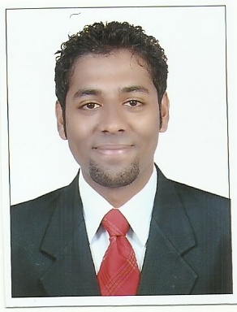

Name : Rohan
Rohan.249612@2freemail.com

Objective:

- To enter into an impeccable relationship with a reputed organization which can utilize mycapabilities and talents to the maximum and provide me the opportunity to contribute towards the success of the organization.
- To strive for higher achievement in life by accepting work challenges and establish myself as a valuable team member of the organizations.
Work Experience:

- Worked as a Machinist in National Iron Works and Sales Executive in Mandovi Motors Pvt Ltd Mangalore. (Aug 2013 – Nov 2013).

- Currently working as a Sales Executive, Cost Estimator and CNC(TRUMPH) Punching and Laser Incharge from December 2013 till date in AL Raien MetallicConst.Ind.LLC, Sharjah.

Personal Skills:
- Ability to adapt quickly to challenges and changing environments.
- Recognised as a creative and practical problem solver.
- Energetic, positive and self-motivated.
- Enthusiastic and willing to assume increased responsibility.
- Quick learner and eagerness to explore and learn.

- Willingness to work as a team.

Educational Qualifications:

Year | Qualification
July - 2013 | I.T.I (Machinist) in Hebich State Board.
July - 2012 | I.T.I (Fitter) in Hebich State Board.
March - 2011 | PUC Commerce in Paduva P.U. College  Mangalore University
March - 2008 | SSLC in St. Aloysius High School  State Board

Additional Qualification:

- Good knowledge of MS Office (Outlook - Word - Excel - PowerPoint - Internet)
- Computer basic
- Basic Pneumatics
- AUTOCAD
(Especially good in sheet metal work drawings)

Declaration:

I hereby declare that the information furnished above is true to the best of my knowledge.

