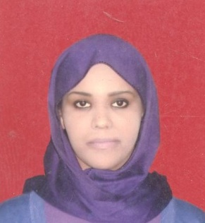
Tasneem

Curriculum vitae
mobile n.o : C/o 0501685421
e.mail: tasneem.250590@2freemail.com
Profile:
Gender: Female
Birthday: 23/10/1987
Place: Omdurman –Sudan
Nationality: Sudanese
Registration N.O: 7340
Religious: Muslim
Marriageable status: Single

Education:
2009 - 27th August 2005 Omdurman Islamic University
Department: Faculty of pharmacy
Degree: Bachelor’s degree (B. Pharm .Honors)
Emphasis: Quality control
Grade: Third Class Honors
Date awarded: August 2009
Graduation Project:
Benzoyl Peroxide
(As a partial fulfillment project for the degree of B. pharm Honors in Quality control pharmacy)
2011-2013
MBA from Khartoum University

Professional Pharmacy Training:
21. February 2010 Name: Putting the patient first UMST 8*Annual international conference
Place: Friendship Hall Khartoum - Sudan
3-6 April 2011 Name: Effective skills for promoting pharmaceutical products (16 Training Hours)
Location: Sudanese pharmacists union

Professional experience:

2010-2014 Job: Pharmacist
Location: Abdeen Pharmacy -Alarbaeen Street
2013 Job: Medical representative
Location: Sandoz Company at Fast International Company –BURRI
2013 Job: Pharmacist
Location: Alsoha Pharmacy - Hay Alrawda
Languages:
Arabic: Native (Speaking, Reading, Writing, Typing)
English: Fluent (Speaking, Reading, Writing, Typing)
French: Beginner (Speaking, Reading, Writing, Typing)

Computer Skills: Very good in Microsoft Office Word, Power point, Excel application

