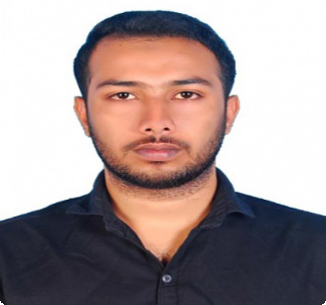
ALFAS UT
Madinat
Madinat.251113@2freemail.com

Summary

I am a disciplined, career oriented and academically sound finance professional looking forward to being associated with a dynamic organization; where I can utilize my academic knowledge and enthusiasm to work hard for my personal growth and for the betterment of the organization. I am a highly motivated team player with excellent team playing capabilities.

Skills

- Well verse in Tally.  - Expert in Peach Tree Version.  - Expert in Quick Books  - Computer fundamentals  - Microsoft Office Suite | - ERP (Enterprise Resource Planning) Software  - Strong communication Skills  - Superior attention to detail  - Self-motivated Professional
Work History

CA Muhammad Sadique TK. B.COM, ACA June 2013 to Jan 2014
Accounting Assistant
- Compiled general ledger entries on a short schedule with nearly 100% accuracy.
- Posted receipts to appropriate general ledger accounts.
- Computed taxes owed by applying prescribed rates, laws and regulations.
- Maintained nearly 100% accuracy in calculating discounts, interest and commissions.
- Prepared Final Accounts (Trading Accounts, Profit & Loss Account & Balance sheet).
- Managed general office administration and maintaining client accounts, prepared and presented weekly report to management and clients.
Education

Professional School of Accounting Oct 2014
PG Diploma
Practical (Manual) & Computerized Financial Accounting (Tally ERP 9.0, Peachtree, QuickBooks & Excel)

Kannur University May 2013
Bachelor of Commerce
Sulfex Mattress India Pvt. Ltd Mar 2013
Academic project done on monitoring the production process and process efficiency.
Personal Details
Driving License : Indian
DOB : 06-01-1993
Languages Known : English, Hindi & Malayalam
Visa Status : Visit Visa (Expire on Dec 15)

Reference

Reference can be provided upon request.

