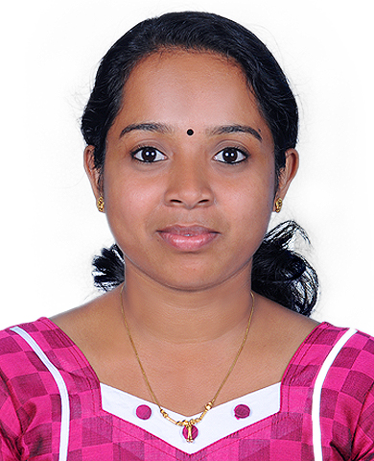
CURRICULUM VITAE

ASWATHY
ASWATHY.254474@2freemail.com
BE: BIOMEDICAL ENGINEER

CAREER OBJECTIVE
Desire a Challenging Position as Biomedical Engineer in a Major Corporation to Continually Seek and Develop Possible Solutions to Health Problems.

Key Skills:
- Biomedical Engineer with 5 years of experience in Biomedical Industry
- The superior experience of working with Critical Care Equipment’s.
➢ Proactively identify areas of obstruction/ breakdown and take steps to rectify the same through the
application of trouble shooting tools.

Professional Experience

- From 20th Nov 2013 - 18th Sep, 2015 & from 22nd March 2016 to 28th March 2017 working with Padiyath Medicity - Hopital du Cinquantenaire, Kinshasa (DR Congo, Central Africa) - 1200 bedded Multi Specialty Hospital as a Biomedical Engineer.
- From April 2012 - November 2013 worked with Polakulath Narayanan Renai Medicity, Cochin - 500
bedded Super Specialty hospital as a Biomedical Engineer.
- From September 2011 - March 2012 worked at Amrita Institute of Medical Science and Research Centre,
Edapally, Cochin - 1500 bedded Hospital as a Biomedical Engineer Trainee.

JOB PROFILE’s:
Equipment’s handling:
Hyperbaric Oxygen Therapy equipment, Multipara monitor, Ventilator, Syringe pump, Infusion Pump, Bipap, Body/Fluid Warmer, DVT pump, ECG Machine, Endoscopes, Digital Video Colposcopy, Laboratory Equipment such as Fully auto Biochemistry Analyzer, Hematology Analyzer, Blood Gas Analyzer, Ultrasound Machine, Ophthalmology equipment such as slit lamp, Auto refractometer, Lensometer, etc.

- To provide first level service and support to equipments, which includes installation, preventive maintenance & breakdown maintenance.
- Inspection of incoming Biomedical Equipment’s as per biomedical department policy, Managing the
servicing as well as maintaining of tools/equipment
- Responsible for Departments Visits, Preventive maintenance and calibration, Coordination of service
personnel for Installation, carrying out Pre-installation requirements etc.
- Biomedical Asset Management and BME Module updation & Maintenance in Hospital information System.
- Proper documentation and record maintenance of department activities.

ACADEMIC CREDENTIALS
Degree | College/University | Percentage | Year of Passing
BE: Biomedical Engineering | Anna University Chennai | 72 | 2011
Higher Secondary Education | St. Sebastian’s H.S.S. Anicadu | 82.5 | 2007
Kerala State Board | St. Sebastian’s H.S.S. Anicadu | 92 | 2005

SPECIAL TRANING RECEIVED & TECHNICAL SKILLS
➢ User training: Attended Operators training program on Beckman Coulter AU2700Plus
➢ Seminar: Partnership for Advancement of Electrosurgical safety Program (PAES) from 3M
➢ undergone hospital training in Meenakshi Medical College, Kanchipuram and Stanley Medical College,
Chennai.

• Programming Languages : Basics of C, Visual Basic
• Software : M. S Office

Personal Profile:
➢ Date of birth : 31-01-1990
➢ Gender : Female
➢ Marital status : Married
➢ Languages Known : English, Malayalam, Hindi & French

Declaration:
Details furnished above by me are true and correct to the best of my knowledge and belief.

