Curriculum Vitae

Present Address

MUHAMMED
MUHAMMED.255369@2freemail.com

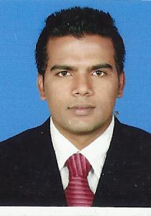

Career Objective

I would like to work with a highly esteemed company which gives me a platform to use my expertise and skills for mutual growth and benefit of company and myself.
Educational Qualification
- High Secondary Education from Board of Higher Secondary Education, Kerala, India. 2010
- SSLC from General Education Department, Kerala, India. 2008
Work Experience
- 2 Years experience as office admin come PRO in Central Institute of Management and Accounts –(CIMA), a Management & Cost Accounting Coaching Centre in Malappuram (2012-2014).
Other Certification Courses:-
- Computer engineering from ISIT Kerala, India (from 29–April–2008 to 29–Jun–2008 )

Computer Knowledge

- Operating systems : MS DOS, [Windows (98, 2000, XP , Vista, Server 2008, 7, 8)]
- Software : MS Office, DTP, Photoshop CS5
- Problem analysis and rectifying most software and hardware related errors

Hardware:-

- Computer assembling and maintenance
- Trouble shooting hardware and software problems
- Installing and configuration all the peripherals, components and drivers
- Installing software and application to user standards
- Monitor disk spaces processor utilization, network utilization related to(server)
- Backup operation and monitoring
- User account creation, deletion modification etc.
- Network card, modem hubs, cable

Strengths:-

- Self –Motive and capable of growing with the company.
- Capable of good interaction with team members.
- Effective communication Skills.
- Basically adored to discipline and integrity.

Knowledge of Languages:-
English : Read / Write / Speak
Malayalam : Read / Write / Speak
Hindi : Read / Write
Arabic : Read / Write

Declaration

I, Muhammed hereby declare that the above-furnished details are true to the best of my knowledge and belief. And also I assure you that I will work and grow with the company according to the expectations and belief kept by the company where I am working.

