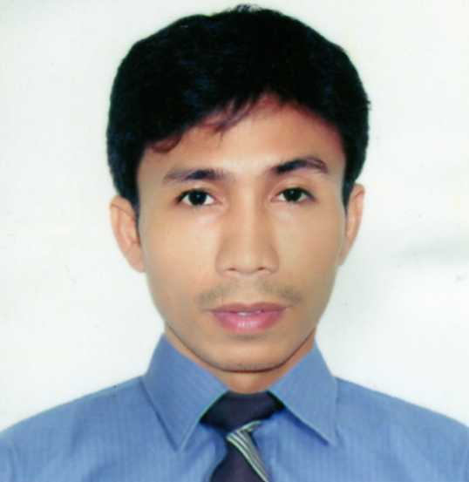
_{LUCINO}
Email add: lucino.256468@2freemail.com

3 years in experienced operate R.o plant.
2 years in experienced AS utility operator.

_{COMPANIES & WORK EXPERIENCES:}

_{A&F ALRASHED COMPANY}
_{LOCATION: riyad,saudi arabia}
POSITION: R.O OPERATOR (From:2014-2015)

_{NATIONAL CATERING COMPANY}
LOCATION: ABUDHABI,UNITED ARAB EMIRATES.
POSITION: R.O OPERATOR (From:2011-2013)

SOYABEAN CRUSHING AND DERIVATIVES
_{LOCATION: YANBU,SAUDI ARABIA}
POSITION: UTILITY OPERATOR(From:2008-2010)

_{JOB DESCRIPTION:}

- Inspect the treatment plant system on a daily basis to ensure effective operation.
- Responsible for start up and shut down the plant in a proper procedure.
- Repair components of the water treatment plant capable and authorized to do by operator.
- Conduct regular water testing to ensure the consistency of water quality.
- Prepares process chemicals and other consumables, ensure correct amount
- Monitoring of chemical tanks level and refill if necessary.
- Adjust chemical dosing pump settings when necessary.
- Refill water truck by its capacity and demand.
- Regulates valves as per pressure demand.
- Adjust and control the releasing steam valve.
- Coordinate to production department the amount of steam demand.
- Conduct regular reading of parameters such as flow rates,gauges and storage tank water level.
- Maintain house keeping in the plant premises.
- Monitoring boiler,etp plant including cooling tower and air compressor.
- Put chemicals into a cooling tower basin.
- Remove foreign objects from etp and cooling tower screen trap.
- Coordinate to supervisor any unusual trouble of the plant specially related to the operation.
- Document all equipments condition and all activitie in the plant while on duty.

_{EDUCATIONAL BACKGROUND:}

ELEMENTARY: Penaplata Elem.Sshool.
_{YEAR GRADUATED:1989}
HIGH SCHOOL: ASSUMPTION ACADEMY
_{YEAR GRADUATED:1993}
COLLEGE:POLYTECNICH UNIVERSITY PHIL.
COURSE: BACHELOR OF SCIENCE IN BUSINESS ADMINISTRATION
YEAR ATTENDED: 1994-1995 (under graduate)
VOCATIONAL:TECHNICAL EDUCATION SKILL DEVELOPMENT AUTHORITY
COURSE: ELECTRICAL INSTALLATION AND MAINTENANCE
_{FROM:August - November 2015}

_{PERSONAL DATA:}
- Born on June 13, 1976 in Samal Davao
- _{Married,with two children}
- _{Weighs: 130 lbs./168cm height}
- _{Religion: Roman Catholic}

