RESUME

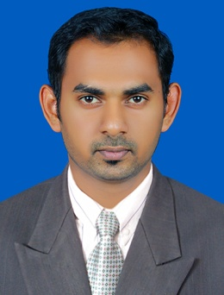
AJIL
Email: ajil.256688@2freemail.com

Career Objective

Aiming at constant up-gradation, both professionally as well as personally, in my career, with emphasis on organizations success through my hard work. I want to work in a challenging environment and derive professional satisfaction there from.

Professional Qualification

Qualification | Institute | year | Percentage
CA (IPCC) | The Institute of Chartered Accountants of India | 2011 | 57.57%
B.Com | University of Kerala | 2012 | 60%

Academic Qualification

Qualification | University/Board | year | Percentage
XII Standard | Board of Higher Secondary Education (Government of Kerala) | 2009 | 89.33%
X Standard | Board of Secondary Education (Government of Kerala) | 2012 | 93%

On Going Education

Course | Institute | Particulars
CA (Final) | The Institute of Chartered Accountants of India | Group 1 –Pass  Group 2, preparing to write in May 2016)
M.Com | Annamalai Open University | First year pass with 67% marks in may 2015 and second year exam will be held on May 2016

Career Profile

Worked for 3 Years from February 2012 to February Chartered Accountants as an Articled Assistant and thereafter as an executive till November 2015.

Work Exposure

- Finalization of Financial Statements.
- Preparation of Auditors Report and Notes to Accounts.
- Compliance with Accounting Standard and other Norms.
- Review of source documents to ascertain compliance with internal control procedure.
- Scrutiny of Sundry Debtors and analysis of Collection Period.
- Review of Cash and Bank Management and reconciliation.

Computer Literacy

- Computer Training of 100 hours recommended by ICAI from Trivandrum branch of ICAI, Covering basics of Computers, Microsoft Tools Tally, Internet etc.
- Hands on experience in office packages like word, excel and Power point.

Interpersonal and Communication Skills

Completed 15 days General Management Communication Skills (GMCS) classes organized by Kollam Branch of ICAI.

Personnel Details
Date of Birth : 08-05-1990
Gender : Male
Nationality : Indian
Marital Status : Single
Language Known : English and Malayalam
Religion : Islam
Date of Issue : 25-05-2015
Date of Expiry : 24-05-2025

Personnel Highlights
- Complete dedication in Work
- Interested in Technologies and innovation
- Good Problem Solving Skills
- Honesty and Disciplined in nature
- Friendly to others
- Team Work

Declaration
I hereby declare that the above mentioned information is correct to best of my knowledge and belief. I bear the responsibility for the correctness of the above mentioned particulars.

Place : SHARJAH (AJIL)
Date : 16-01-2016

