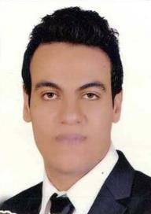
Karim

Karim.256837@2freemail.com

Work Experience

Orange Egypt
Position:
Country:
Reference:

Description:

Jan 2017 Tell Nov 2017
Sales Supervisor
Egypt
Available

- Handling owners for STS and review his sales every month

- Responsible for every sales agent about their ( attitude, performance, targets )

- Achieve shops target

Orange Egypt |  | Jan 2016 Tell Dec 2016
• | Position: | Sales Indoor
• | Country: | Egypt
• | Reference: | Available

- Description

- Knowledge about phone and accessories

- Assist all customers with highly customer service

- Provide right information and achieve store target

Vodafone Egypt |  | Feb 2015 Tell Dec 2015
• | Position: | Call Center
• | Country: | Egypt
• | Reference: | Available

- Description

- Receiving call from customers and assist their needs

- Handle customer complains

- Give proper customer service

Objective

I am currently looking for a full time sales representative position in an environment that offers great challenge, increase benefits for my family and the opportunity to help the company advance efficiently and productively.

education

bachelor of law, faculty of law, may 2013, mansoura university, Egypt .

Certificates

- Master In Law from Mansoura University 2016

- Diploma in Public Law May 2014
- Business Etiquette orange Mar 2015

Soft Skills Course

(Leadership skills Presentation skills, Selling skills, Body language, Communication skills, marketing skills)

personal skills& Computer Skills

- Very good command of English ( spoken & written )

- Excellent in building relations

- Able to work under pressure

- Enjoy challenges

- MS Office Group (2003,2010)

- MS Windows, Internet

All References upon request

