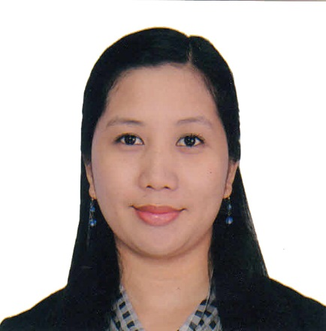

KRIST
Al QUSAIS
DUBAI, U.A.E
EMAIL: krist.257346@2freemail.com

CAREER OBJECTIVE
I look forward to working in a reputable company that will give new challenge and growth to my career and wherein I can effectively utilize my organizational skills, administrative experience and my customer service expertise.
AREAS OF EXPERTISE
$∎$ Customer Service Management $∎$ Client Management $∎$ Operation and Scheduling $∎$ Office administration $∎$ Business Development
PROFESSIONAL EXPERIENCE
- EMIRATES SERVICES L.L.C, DUBAI, U.A.E (Company deals with facilities management)
Customer Coordinator (Mar 2014 to Present)
Company deals with facilities management

- Prepares reports, quotations and contracts
- Coordinates with clients regarding schedule
- Responsible for updating invoice files and doing all record keeping
- Answer all clients general inquiries through phone calls and emails

- SITEL PHILIPPINES, Eastwood Libis Quezon City, Philippines
Customer Service Representative (Nov 2010 to Jan 2014)

- Making flight reservations for an Australian Airline
- Assisting guests with inquiries regarding flights
- Resolving guests complaints

- Cyber City Teleservices Clark Freeport Zone, Angeles City Pampanga, Philippines
Customer Service Representative (May 2006 to April 2010)
Responsibilities:
- Assisting customers with their general inquiries and resolve their complaints
- Assisting technicians in closing their jobs for a cable company
- Did some soft selling for an order entry account
PROFESSIONAL SKILLS & QUALIFICATION
- Possess 9 years of professional experience in providing quality customer service
- Possess excellent communication and interpersonal skills
- Quick learner and possess creative problem solving skills
- Ability to follow up with customers in a timely professional manner.
- Good time management and organizational skills and can complete the tasks promptly and accurately.
- Familiar with MS Office (Word, Excel, Access, Power Point) Adobe Photoshop

SEMINARS ATTENDED:
- Sabre Interact Training Sitel Philippines, Eastwood Libis, Quezon City, Philippines
January 2013
- Housekeeping Training St. Mary’s Angels College of Pampanga, Sta. Ana, Pampanga
February 2009
- The 9th IT Convention Aliw Theater, Star City
February 19, 2004
- Advanced Networking Systems Technology Institute, City of San Fernando, Pampanga
Summer 2004
- Macro Media Flash Systems Technology Institute, City of San Fernando, Pampanga
November 2004
- Typing Systems Technology Institute, City of San Fernando, Pampanga
2001 – 2002
- Trouble Shooting Systems Technology Institute, City of San Fernando, Pampanga
Summer 2002
ACADEMIC PROFILE
Bachelor of Science in Computer Science
STI College San Fernando Pampanga
Graduated in the year 2005

PERSONAL PROFILE
Languages Known : English, Tagalog
Interests and Pastimes : Reading, Music, Movies
Born : Dec. 17, 1983
Marital Status : Single
Nationality : Filipino

