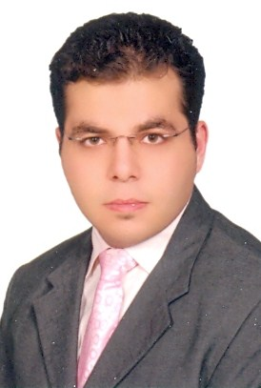
Ahmed

Email: Ahmed.257411@2freemail.com

Personal Details

Date of Birth June 15th, 1985
Nationality Egyptian
Marital Status Married
Driving License UAE

Summary

I am a passionate and dynamic IT professional whoprideshimself on ability to deliver extraordinary levels of customer service and provide creative solutions. I am responsible for directing and managing the daily operations and projects of the computer operations department and also leading the IT team, to efficiently and effectively carry out IT projects and support the company’s users with company communication and IT infrastructure and systems.

Qualifications & Experience

- B.Sc. of Engineering, Computers & Information System Technology, May 2007
- 6+ Years of IT Customer Solutions experience with recognized experience in a Supervisory positions in a high technology hospitality corporation.

Certification &Training

- CCNA 200-120 – December 2015 (Certified)
- MCSE, Exchange – NLP Tech Institute Dubai – 2016
- Time Management, Goal Setting, Leading Others, (IHG Merlin) - 2015
- Craft Training Certificate (IHG Merlin) - 2014

Languages

- Arabic - Mother Tongue
- English - Very Good – Spoken & Written

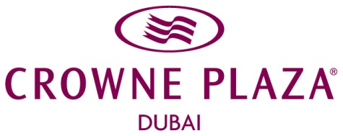
CAREER HISTORY
April 2013 –October 2015
Position: IT Supervisor
Employer: Crowne Plaza Dubai - IHG
Responsibilities include but are not limited to:
- Review business cases for all investments throughout company projects to ensure that they are cost effective and that their return on investment and enhancements are beneficial.
- Implement policies and procedures regarding how problems are identified, received, documented, distributed, and resolved.
- Understand of operational needs as it relates to IT and work effectively with operational management in the coordination of IT projects and identifying operational technology needs.
- Evaluate new information systems products or services and suggest changes to existing products or services to better aide the business needs.
- Ensure property is in compliance with appropriate Policy and Information Security Manual, Implement solutions as directed to resolve discrepancies.
- Assist in disaster recovery and business continuity as it relates to technology.
- Helps business operations utilize information systems to improve efficiency.
- Conduct periodic inventories of applications and hardware, provide accurate reports.
- Perform routine desktop, server backup and routine preventative maintenance.

Achievements:
- S/W & H/W IHG Pilot Upgrade & Migration (FBM, SUN 6, Opera 5.x, Micros Simphony 1.6 MR9 andSurfsonix HSIA)
- Wifi Coverage Survey with Cisco & Ruckus (Rooms, Outlets and Public Areas).
- Audio & Video renewing survey for main ballrooms & meeting rooms.
- Design & implement departments & public share network drives through AD GP.
- Standardize Network Devices IDs.
- Participate in rearranging Data Centre and raised floor project implementation.
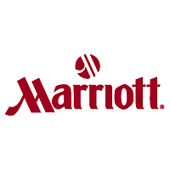
September 2012 –March 2013
Position: IT Supervisor
Employer: Taba Heights Marriott Resort - Egypt
Responsibilities include but are not limited to:
- Manage technology assets life-cycle. Ensure that technology assets are secure and well-maintained in accordance with policies and standards.
- Recommend appropriate maintenance strategies to ensure uninterrupted systems usage and proper backup and recovery procedures are adhered to.
- Keep current with technology updates to ensure technology opportunities are taken advantage of, whether the opportunities relate to speed, improved processing, cost efficiencies, etc.
- Monitor system performance, identify and rectify complex system malfunctions.
- Maintain proper documentation for all the systems related activities, architecture, structures, procedures and changes.

Achievements:
- Upgrade all PCs to Win7 Marriott Int. standard.
- Fiber Infrastructure all over property for upgrading guest HSIA solution.
- Full WIFI coverage all over property.
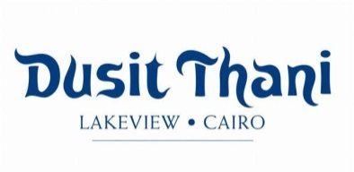
October 2009 – July 2012
Position: IT Supervisor
Employer: DusitThani Lakeview (Opening) – Egypt
Responsibilities include but are not limited to:
- Administer computers, wireless access points, printers, routers, switches, firewalls, phones, UPS smartphones, attendance machine, software deployment and licenses, security patches.
- Manage end user accounts, permissions, access rights, and storage allocations.
- Providing support, including procedural documentation and relevant reports.
- Maintain a sufficient inventory of all office and computer supplies.
- Inquiry, collect IT quotes, follow up with Procurement for LPOs.
- Monitor and maintain computer systems and networks.

Achievements:
- VLAVs infrastructure for admin & guest networks – Cisco Infrastructure.
- WIFI coverage for all public areas & restaurants.
- Upgrade Opera V5, Micros 9700& MC.
April 2009 – October 2009
Position: IT Coordinator
Employer: Hyatt Regency Taba Heights – Egypt
Responsibilities include but are not limited to:
- Install, configure, maintain, monitor, and troubleshoot end user workstation hardware, software, networked peripherals devices, cabling, and networking hardware and software products.
- Maintain all network hardware and equipment, including routers, switches, hubs and UPS’s.
- Perform daily system monitor and verify the integrity and availability of all resources.
- Configure MS Active Directory and Group Policy management to apply the rules.
- Evaluate newly acquired software and hardware to ensure proper functioning
- Coordinate IT related projects.

Professional Experience

- MS Windows 7, 8, Server 2003, 2008, 2012 Implementation & Support
- MS Office 2003, 2007, 2010, 2013
- MS Internet Security & Acceleration Server 2006
- Cisco VOIP Unified Call Manager 4.3 Administration
- AVAYA Integrated Management * Micros Fidelio Simphony 1.6 MR9
- Locatel IP TV System * Micros Fidelio Materials Control V8.6
- Symantec Backup Exec for Windows Servers * Micros Fidelio POS 9700
- Symantec Endpoint Protection Manager * Micros Fidelio Opera V4.0, V5.0
- Kaspersky 10 antivirus & internet security * Sun System Back office V6
- Trend Micro Office Scan * Sky Horizon Quality Management
- Acronis True Image Enterprise Server 9.1 * Food Beverage Materials System
- Nomadix Access Gateway v. 7.4/8.2 * ACT Payroll & HR System
- Surfsonix HSIA V5 * PayTRAX Personnel & Payroll System
- Vision Vingcard V5.5 * Hits Payroll & HR System

Personal Skills

- Generate new ideas, take risks, support change, encourage innovation, solve problems creatively.
- Achieve and exceed goals including performance goals, budget goals, and team goals.
- Apply consistent performance standards, handle performance problems decisively and objectively, direct but diplomatic, provide guidance and assistance to improve performance.
- Understand duties and responsibilities, have necessary job knowledge, have technical skills, understand company mission/values, keep job knowledge current, in command of critical issues.
- Strong communications, analytical skills and Ability to work under stress, handling emergency cases effectively and to work within a team.
- Utilize interpersonal and communication skills to lead, influence, and encourage others.
- Manage time well and possess strong organizational skills.
- Use problem solving methodology for decision making and follow up.
- Prioritize and manage many open cases at same time, work with multiple levels of staff.
- Rapidly establishing a good working relationship with customers and coworkers.
- Promote efficiency, confidence, courtesy and an extremely high standard of social skills.
- Display a pleasant manner and positive attitude at all times and to promote a good company image to guests and colleagues.
- Demonstrate pride in the workplace and personal appearance at all times when representing the company thus identifying a high level of commitment.

Willing to have your confidence

