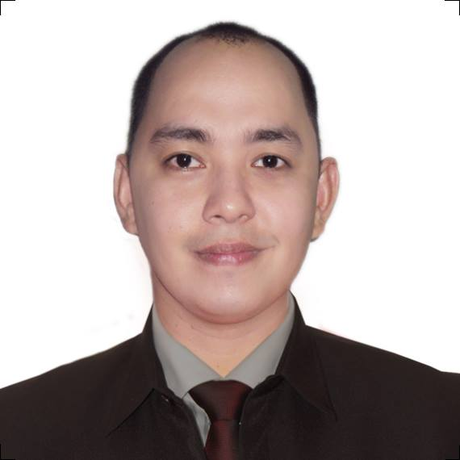
Joseph
E-mail Address: joseph.258193@2freemail.com
Contact Number: C/o 0505891826

OBJECTIVE

To seek a full-time challenging position that would give me a rewarding experience and an opportunity to contribute to the growth of the organization with my skills, knowledge and experience.

PERSONAL INFORMATION

Age : 29 years old
Date of Birth : 26th September 1986
Nationality : Filipino
Gender : Male
Marital Status : Single
Availability : Immediate

WORK EXPERIENCE

AGGASYS SOLUTIONS, SINGAPORE PTE LTD ADMIN SUPERVISOR
(Dell Singapore Service Provider) Nov 28 2011 to Mar 3, 2014
40 Jalan Pemimpin #04-09
Tat Ann Building Singapore 577185

- Oversee projects and monitor day to day operation of the company.
- Distributing work load evenly and making sure team’s performance level are maintained.
- Provide excellent service experience to customers through phone by handling customer complaints and scheduling of service appointments.
- Maintain and provide periodic progress report and feedback to the manager.
- Answer engineer queries about server installation, procedure and customer information.
- Coordinate with various staff for operational support activities of the unit; serve as a liaison between departments and operating units in the resolution of day-to-day administrative and operational problems.

IZONE TECHNOLOGIES LEVEL 2 TECHNICAL SUPPORT REPRESENTATIVE
Help Gurus USA July 2011 to October 2011
Emerald Avenue, Manila Philippines

- Provide complete diagnosis of any technical problem with a comprehensive solution, including repair, updates and optimization of customer’s computer, software and/or peripherals.
- Remove viruses and protect customer’s computer against malware, spyware and other aggressive and malicious online attacks.
- Audit security settings, configure anti-virus and anti-spyware applications, scan pc and quarantine viruses.

SYNNEX – CONCENTRIX TECHNICAL SUPPORT REPRESENTATIVE
Dish Network USA June 2010 to March 2011
Eastwood City, Manila Philippines

- Provide effective and consistent technical support for cable subscribers.
- Interact with customers; provide program information, rules, regulations, and procedures.
- Explain the breakdown of their monthly bill, receive complaints and provide resolution for disputes.

WNS GLOBAL SERVICES LOYALTY AND RETENTION OFFICER
WNS Global Services June 15, 2009- April 26, 2010
T-Mobile UK
Araneta Center, Manila Philippines

- Retaining member who wants to cancel service by providing the importance of the product and services and offering competitive plans.
- Completed training for customer retention.
- Support mobile phone, mobile broadband and retention calls.
- Deliver world class customer service and build customer satisfaction and loyalty.
- Provide effective and timely resolution of a range of customer enquiries.
- Strive for first call resolution of customer issues.
- Complete ongoing training to stay abreast of product, service and policy changes.
- Increase the customer experience by providing information on new products, price plans, and services that suit their needs.

ICT MARKETING SERVICES CUSTOMER SERVICE REPRESENTATIVE Virgin Mobile USA Sept 17, 2007- April 2009
Marikina City, Manila Philippines

- Perform exceptional customer service and provide customer satisfaction at all times by receiving and responding to telephone inquiries, complaints and other concerns.
- Handles mobile phone and broadband queries, troubleshooting handsets, explaining bill, product and services.
- Provide solution for call disputes.

ACHIEVEMENTS RECEIVED

Batch Topper Product Training at WNS Global Services
August 14, 2009

Customer Champion Award for Best Customer Service for the Month of September
October 18, 2009

Customer Champion Award for Best Customer Service for the Month of October
November 12, 2009

CERTIFICATION OF COMPLETION

Completed World Class Customer Service Training for below company:
ICT Marketing Services – October 2007
WNS Global Services – August 2009
Synnex-Concentrix – July 2010

EDUCATIONAL BACKGROUND

College Bachelor of Science in Legal Management
SY 2003 – 2005 San Beda College – Manila
Manila, Philippines

Secondary Roosevelt College
SY 1999 – 2003 Quezon City, Philippines

Primary Pura V. Kalaw Elementary School
SY 1991 – 1999 Quezon City, Philippines

